# Week 1: Introduction to Onshape - “Getting Started”

|  |  |
| --- | --- |
| **Concepts** | * Creating an Onshape account * Navigating a 3D environment * Explaining sketch-based modeling * Introducing the 4 foundational features (extrude, revolve, sweep, and loft) * Transitioning from 2D to 3D * Introducing basic sketching * Appendix A: keyboard shortcuts, mouse and touchpad gestures, view tools * Appendix B: navigating documents, account settings, subscription plans |
| **Models** | * Cylinder shell - used for intro to interface, visualization/viewing * Models that already have sketches - students must create features * Existing public models - search and copy to workspace |
|  | |

# 

# 

# Welcome to the Onshape College Curriculum

Welcome! This curriculum is designed to introduce you to Computer-Aided Design (CAD) using the Onshape Full-Cloud CAD platform. This content has been created for use in a 12-week course taught by an instructor at any college, university, or technical school with a focus on design and engineering. This curriculum introduces you to not just CAD, but also to tried and true methods of designing products for manufacturing, as well as design techniques that are unique to Onshape and full-cloud CAD.

Each week is divided into a Lesson Plan, Homework, and an Assessment. Instructors should feel free to modify this curriculum as they see fit to best deliver a valuable learning experience to their students.

The core curriculum is a step-by-step walkthrough of most features in Onshape, with an equal focus on the “How” and the “Why.” After this course, you should be able to easily apply the skills learned to any other parametric CAD program and engineering setting. In addition to the instructions, there are also *“Pro Tips”* which are designed to accompany some of the more advanced topics. *Pro Tips* have been written from the perspective of a professional with the intent to quicken or clarify the design process.

Let’s begin!

# Getting Started

Before we start designing in Onshape, we need to create an account and sign in.

## Creating an Account

Unlike most CAD software, you don’t have to download or install anything to use Onshape. But, you do have to create an account. Once you have an account, you can log into Onshape from any computer or mobile device as long as you have an internet connection. Follow the steps below to create your account:

1. Open a browser window, and go to [www.onshape.com/signup](http://www.onshape.com/signup) for the Free Plan, or go to [www.onshape.com/edu/signup](http://www.onshape.com/edu/signup) to sign up for the free Education Plan (recommended for all teachers and students).
2. Alternatively, go to [www.onshape.com](http://www.onshape.com) and click the [Create Account] button at the top of the page.
3. Answer a few questions and click [Create Free Account].
4. Check your email for a confirmation email and follow the link within.
5. You’re in!

## Signing In

1. Navigate to [http://cad.onshape.com](http://cad.onshape.com/).
2. Enter the email address you used during the sign-up process.
3. Enter your Onshape password.
4. Click [Sign in].

And that’s it! You’re now on the Documents page.

### The Documents Page

* The Documents page is the first page displayed after signing in. While on any other page, click the Onshape logo in the top left to return here.
* Since this is your first time logging in, the “Tutorials & Samples” filter is active. Feel free to browse these tutorials if you like.

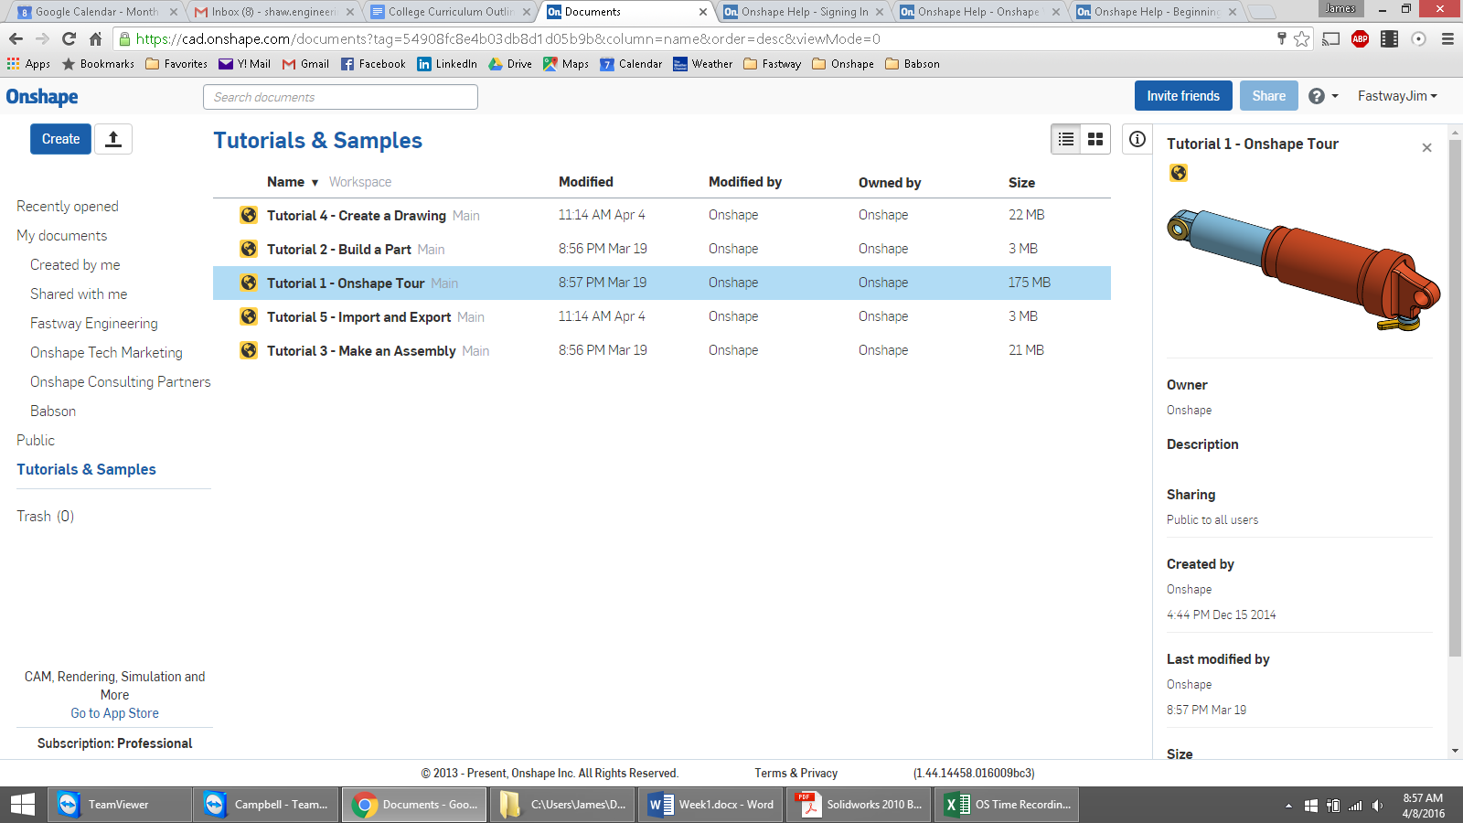

Additional details about the Documents page (including document filters, sharing documents, and changing units) are under “More About Your Onshape Account” in Appendix B.

**One cool thing to take note of:** notice the Share button in the top right corner. Can you guess what this is for? Onshape actually lets you share and simultaneously collaborate on documents just like you might over an essay in Google Docs. More on this in Week 6.

# Learning to Think in 3D

Let’s get right into it and look at an existing 3D model in Onshape.

1. From the Document screen, click on “Public” from the left panel, and search for a model called “College - Casting Fixture Demo”. If you can’t find it, click [here](https://cad.onshape.com/documents/57092e16e4b0b7d723cf1127/w/436e8c84e0076428ce162d7f/e/3fc169118c16ca90beee0f70).
2. Click on the name to open it.
3. The Document will open, and you will see the **Part Studio**:

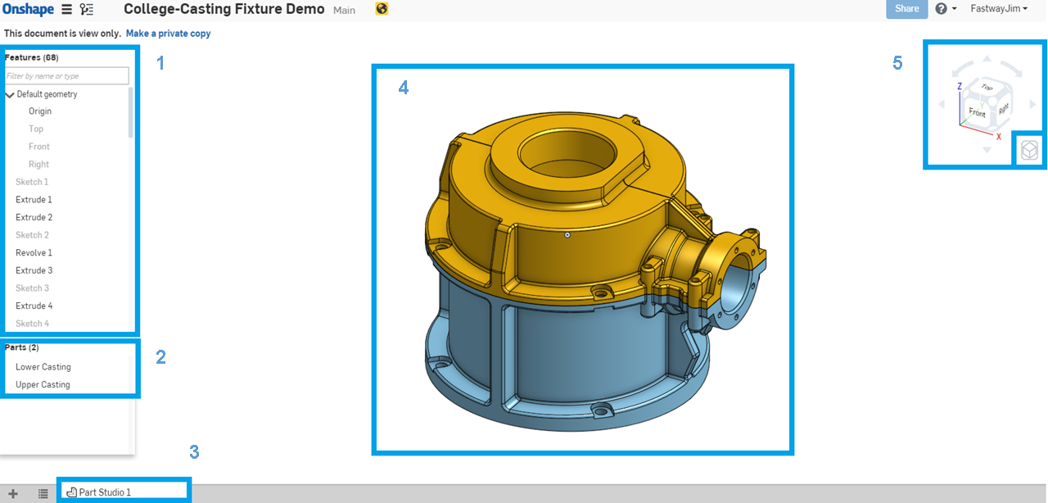

1. There are 5 main areas of interest:
2. **The Feature List:** Features are used to create CAD geometry and this list shows the order in which they were created. (Scroll down in the left panel to see them all.)
3. **The Part List:** This is where parts are listed, in chronological order, as they are created.
4. **Tabs:** Documents can have multiple tabs such as Part Studios, Assemblies, Drawings, and more. More on this later.
5. **The Graphics Area:** Where we view, create, and modify geometry.
6. **The View Cube:** This helps us rotate and view our model.

Let’s get a better understanding of the Graphics Area and the View Cube through the following exercise.

## In-Class Exercise #1:

Hover over the View Cube. Notice that parts of the cube (the edge, corner, or face of the cube) become highlighted. Click on the “Front” face. The model should rotate and show us its front view, like in the picture below.

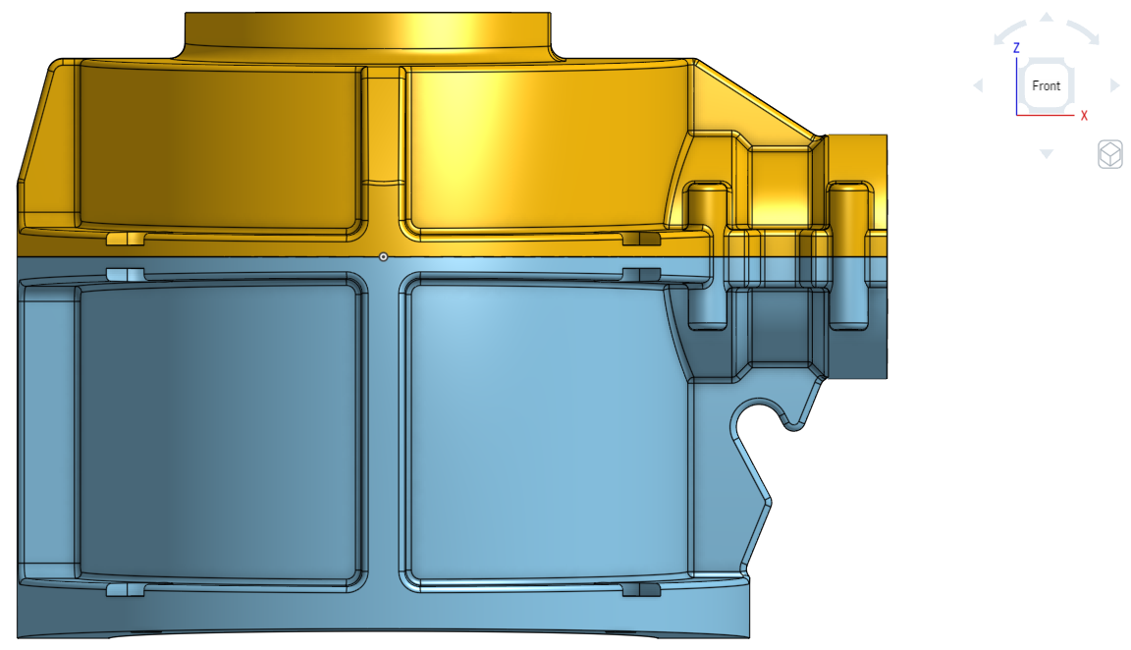

Now play around by clicking on the edges and corners of the View Cube. Click on the corner in between the “Front”, “Top”, and “Right” faces, and we will be brought back to the default orientation.

Besides **rotating**, you can also view your model by **zooming in and out**, and **panning** (which translates the model side-to-side without rotating).

Most people like to use their mouse when using CAD. If you have a mouse:

1. Try rotating the model by holding down the right mouse button and dragging. 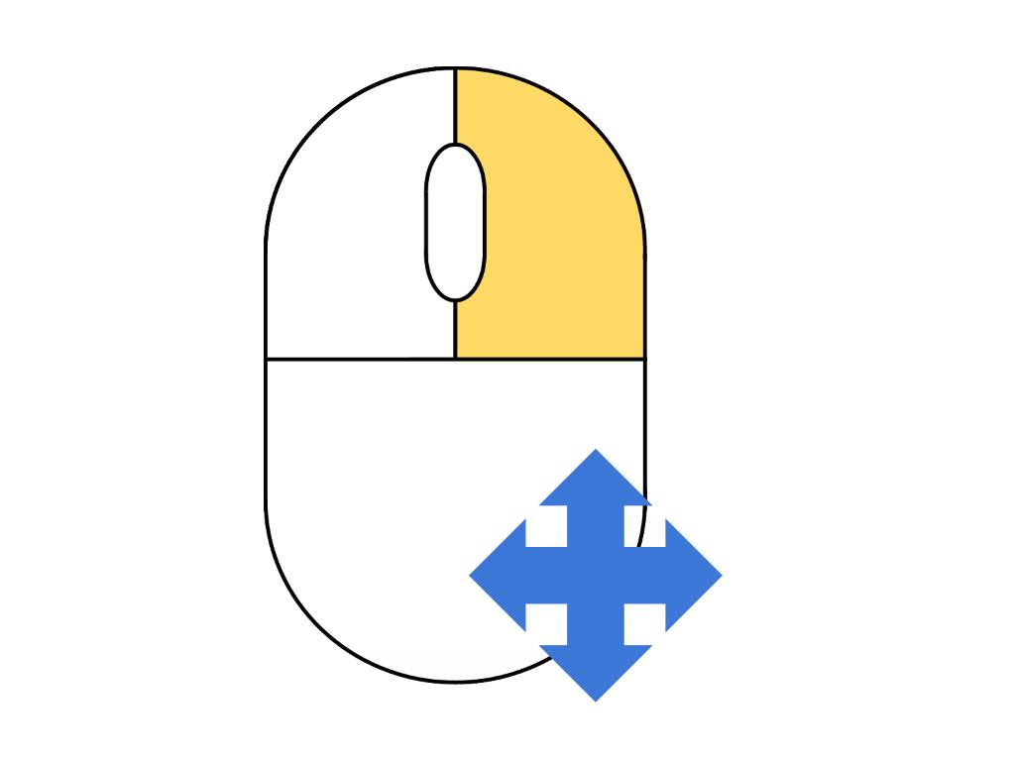Notice that the orientation of the View Cube always matches the orientation of the model, as shown below:

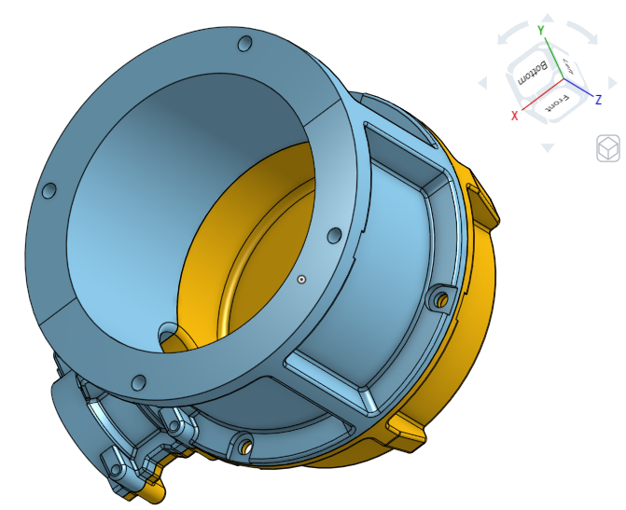

1. Now trying zooming in and out by scrolling down and up, respectively. 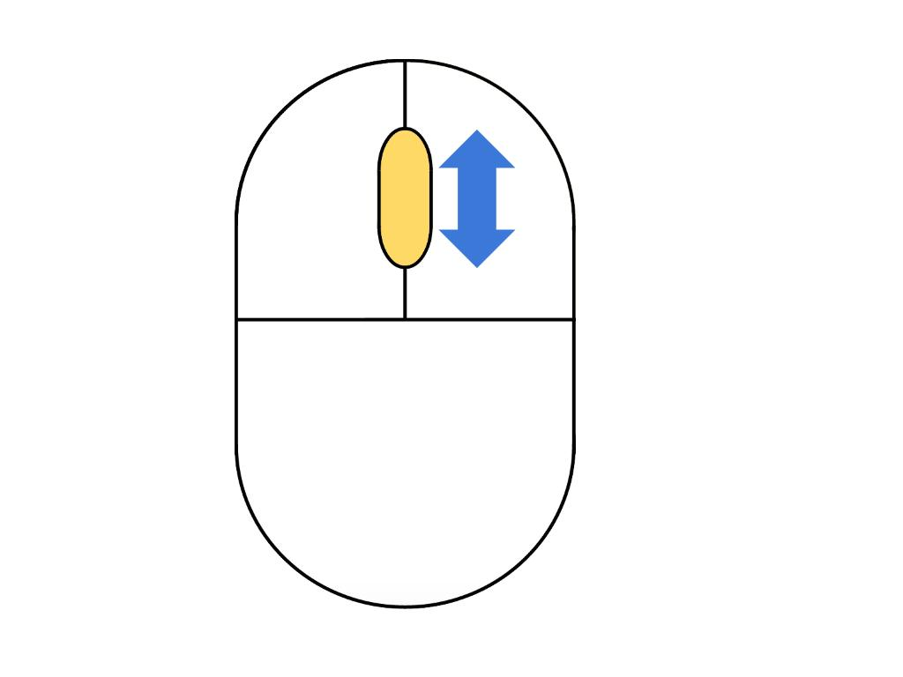 Keep an eye on where the mouse cursor is, as the zoom is always centered on that cursor. If the cursor is over your model, you zoom into the model. If the cursor is over to the side, then you’ll zoom in to blank space. You can also flip the direction of your scroll in your account preferences.
2. And now, try panning by doing the same gesture as rotating, but while holding down the **CTRL** key (even on a Mac). 

If you don’t have a mouse, use the touchpad to complete these steps. Refer to “Mouse and Touchpad Gestures” under Appendix A for the full list of touchpad controls.

*Pro Tip: When zooming in and out and rotating, it’s quite easy to get “buried” or “lost” in the model, especially with large parts. Sometimes, you can even zoom in too far and the model is completely off the screen! To quickly zoom to fit and center the entire model to the screen, select the “****f****” key on the keyboard. In fact, many professional CAD Designers naturally operate with one hand on the mouse, and the other on the keyboard at all times.*

# Sketch-Based Modeling and the Four Foundational Features

We’ve learned how to view models, but how do you make them? This 3D object was actually made by many 2D sketches and 3D features. The concept of making a 3D model out of a combination of 2D sketches and 3D features is called **Sketch-Based Modeling** and is common to many professional CAD systems.

To understand the concept of sketch-based modeling a little better, let’s open a document first. Go to “College - Sketch-Based Modeling” and click on “Make a private copy” located on the top. Choose [Private] and click [OK] on the dialog box. You should land on this page:

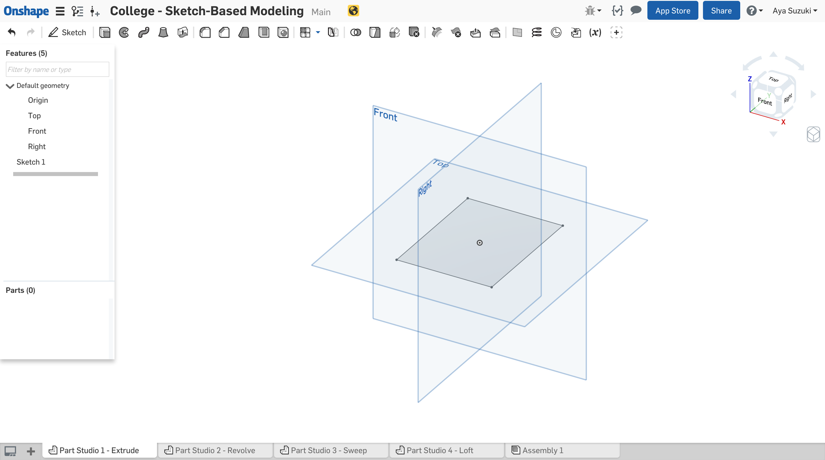

This time, the interface looks a little bit different, because this is a part that we own rather than a public part that we can only view). We now have a feature toolbar at the top of our screen. We’ll focus on just a few features on the top left:

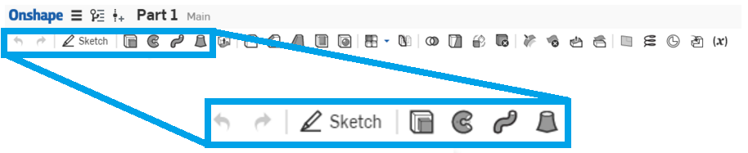

The four rightmost icons in the blue box represent **Extrude**, **Revolve**, **Sweep**, and **Loft**. These are known as the 4 foundational features - important 3D features that modify a 2D sketch. These tools are extremely useful in sketch-based modeling. In fact, you can make almost any geometry just using these four features. Notice that we’ve also written these 4 keywords in the tabs on the bottom of the screen:



Let’s learn what these features are by following these steps:

## Extrude

1. Make sure you’re in “Part Studio 1 - Extrude”. You should see a rectangle located in the middle. This rectangle is your 2D sketch for this example.



1. Now we’re going to **Extrude** this rectangle. This means we’re going to take the shape in the sketch and pull it in a straight direction (i.e. a constant cross section is extruded in a straight direction). If we pull a rectangle in a straight direction, we can imagine it forming a box. Let’s see what happens.
2. Click on the Extrude tool in the feature toolbar.

*Pro Tip: To keep the graphic screen clean, there are no text on the icons. However, if you hover the mouse over the icon, descriptive text (including keyboard shortcuts) will quickly pop up, and if you leave the mouse hovering over the icon for about 2 seconds, an even more helpful dialog box will pop up. For example, if you hover over Extrude:*

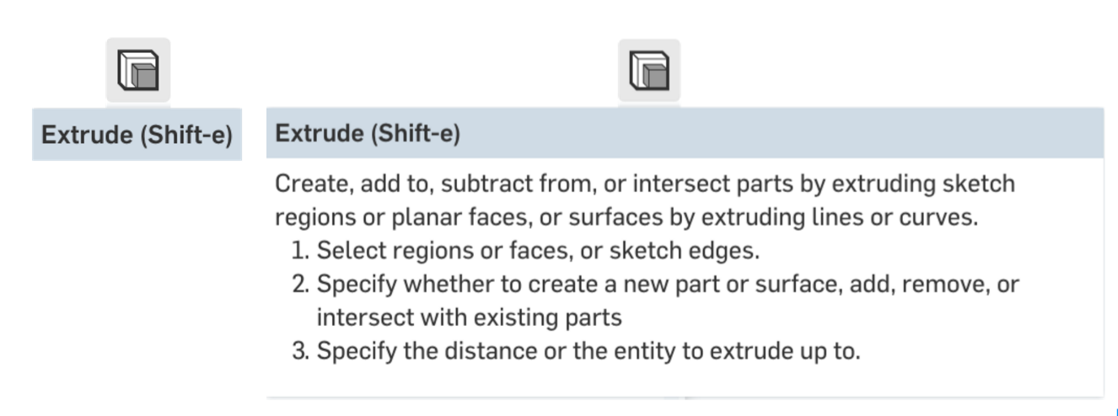

1. A dialog box should show up. Click anywhere in the gray area within the rectangle. The dialog should end up looking like this:

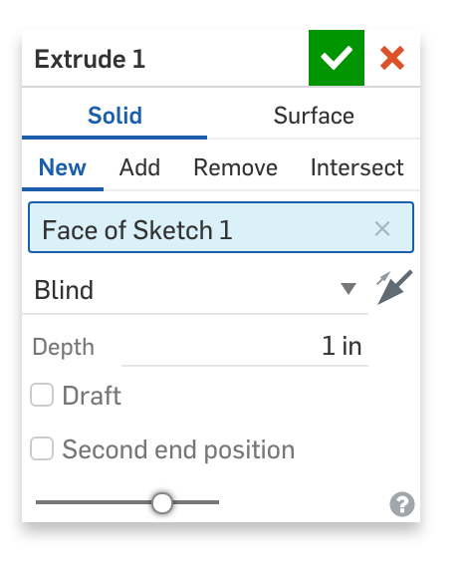

1. Onshape will generate a preview of a box, just as we predicted. Click the green check mark  to accept.
2. You have successfully created a 3D model (the box) out of a 2D sketch (the rectangle) by **extruding**.

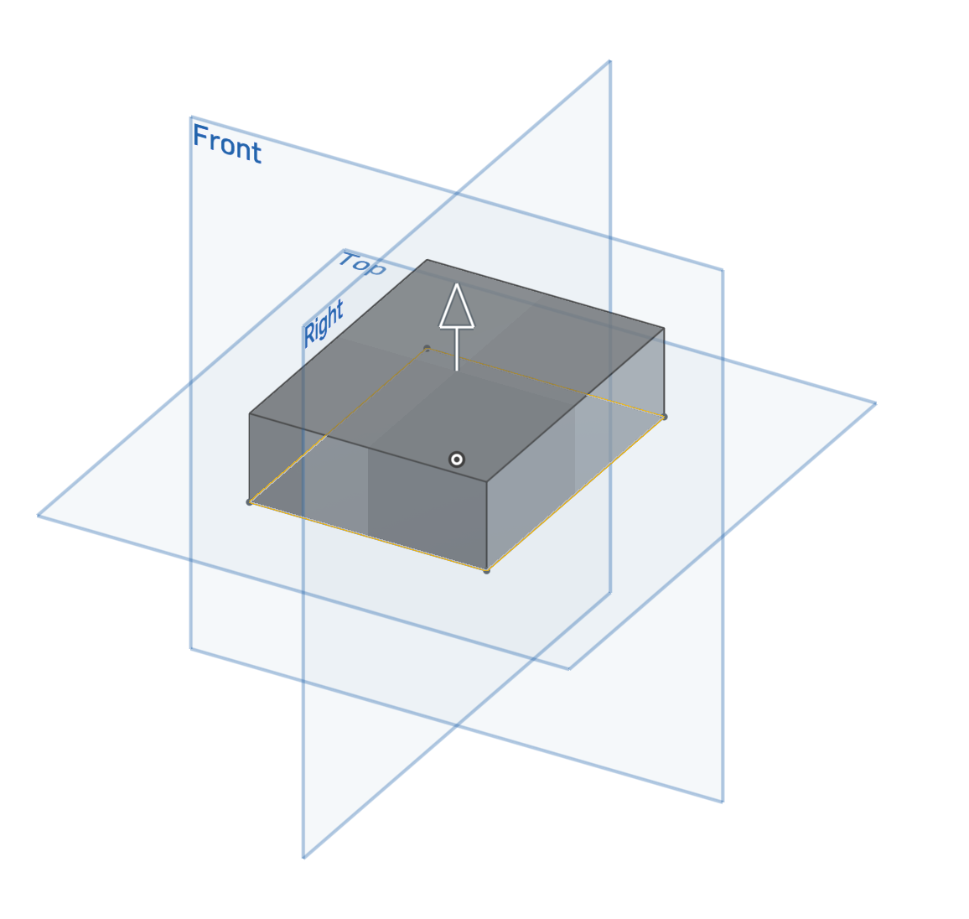

## Revolve

1. Now let’s **Revolve** a sketch. Click on the “Part Studio 2 - Revolve” tab along the bottom. You’ll see a sketch like this:

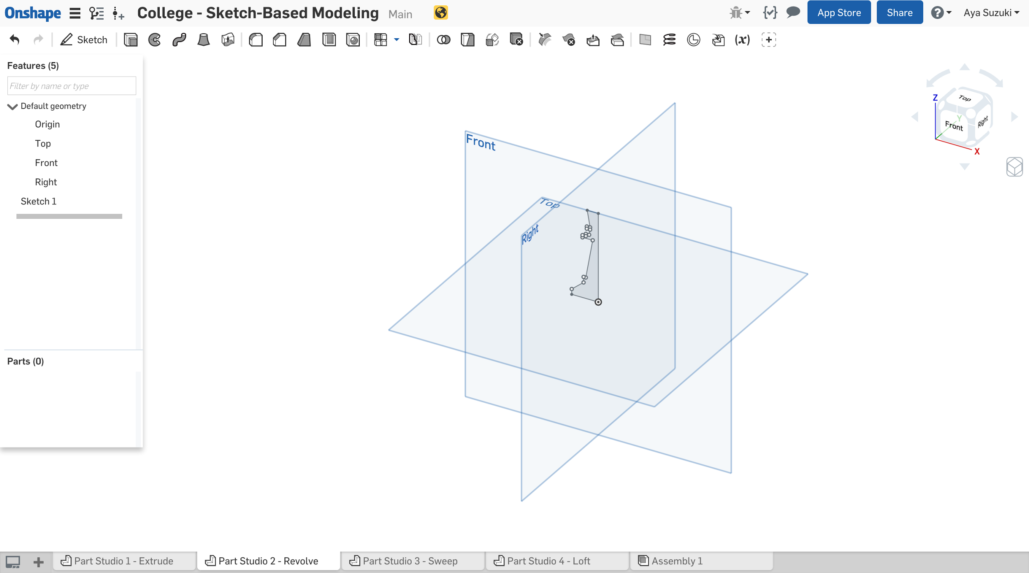

1. Let’s think about how this 2D sketch can become a 3D model. Imagine you cut this shape out on paper. Now imagine a stick taped to the vertical line, which we will call the **axis of revolution**. What happens when you spin the stick really fast? What do you see? You might see a 3D object – in this case, the start of a chess piece. This idea of spinning a 2D sketch with a constant cross section around an axis of revolution is called **revolving**.

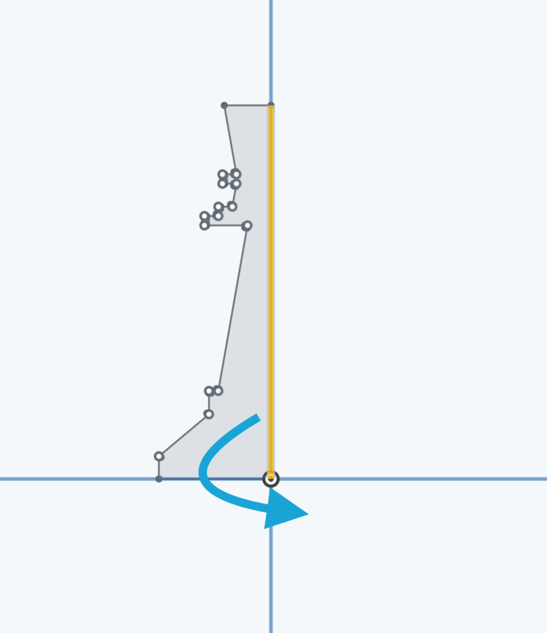

1. Click on the Revolve tool . A dialog will show up. Notice that “*Faces and sketch regions to revolve*” is already highlighted blue.

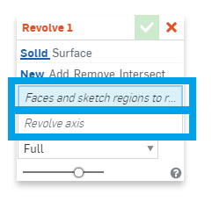

1. Click the sketch. Then click on “*Revolve axis.*” It should highlight blue:

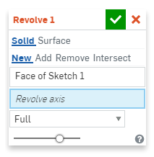

1. Then select the vertical line. The dialog box should end up looking like this:

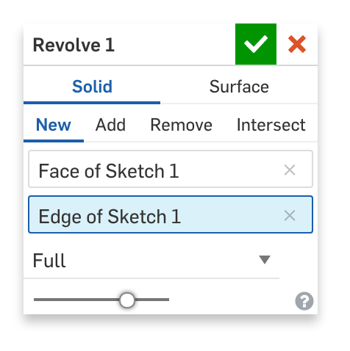

1. Click the green check mark  to accept.
2. You have successfully created a 3D model (the chess piece) from a 2D sketch by **revolving**!

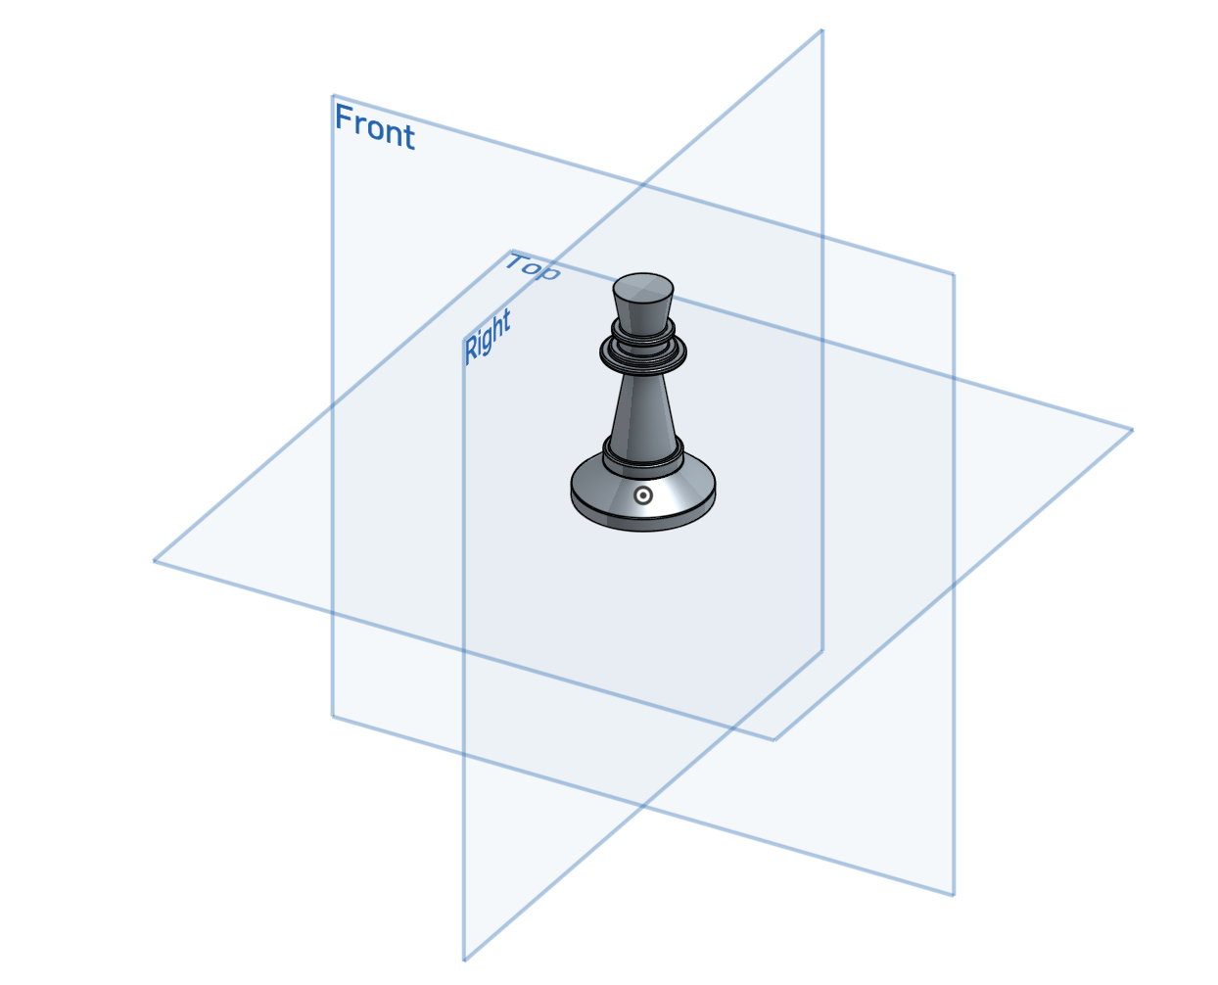

## Sweep

1. Now let’s **sweep** a sketch. Click on “Part Studio 3 - Sweep”. You’ll see two sketches this time, like this:

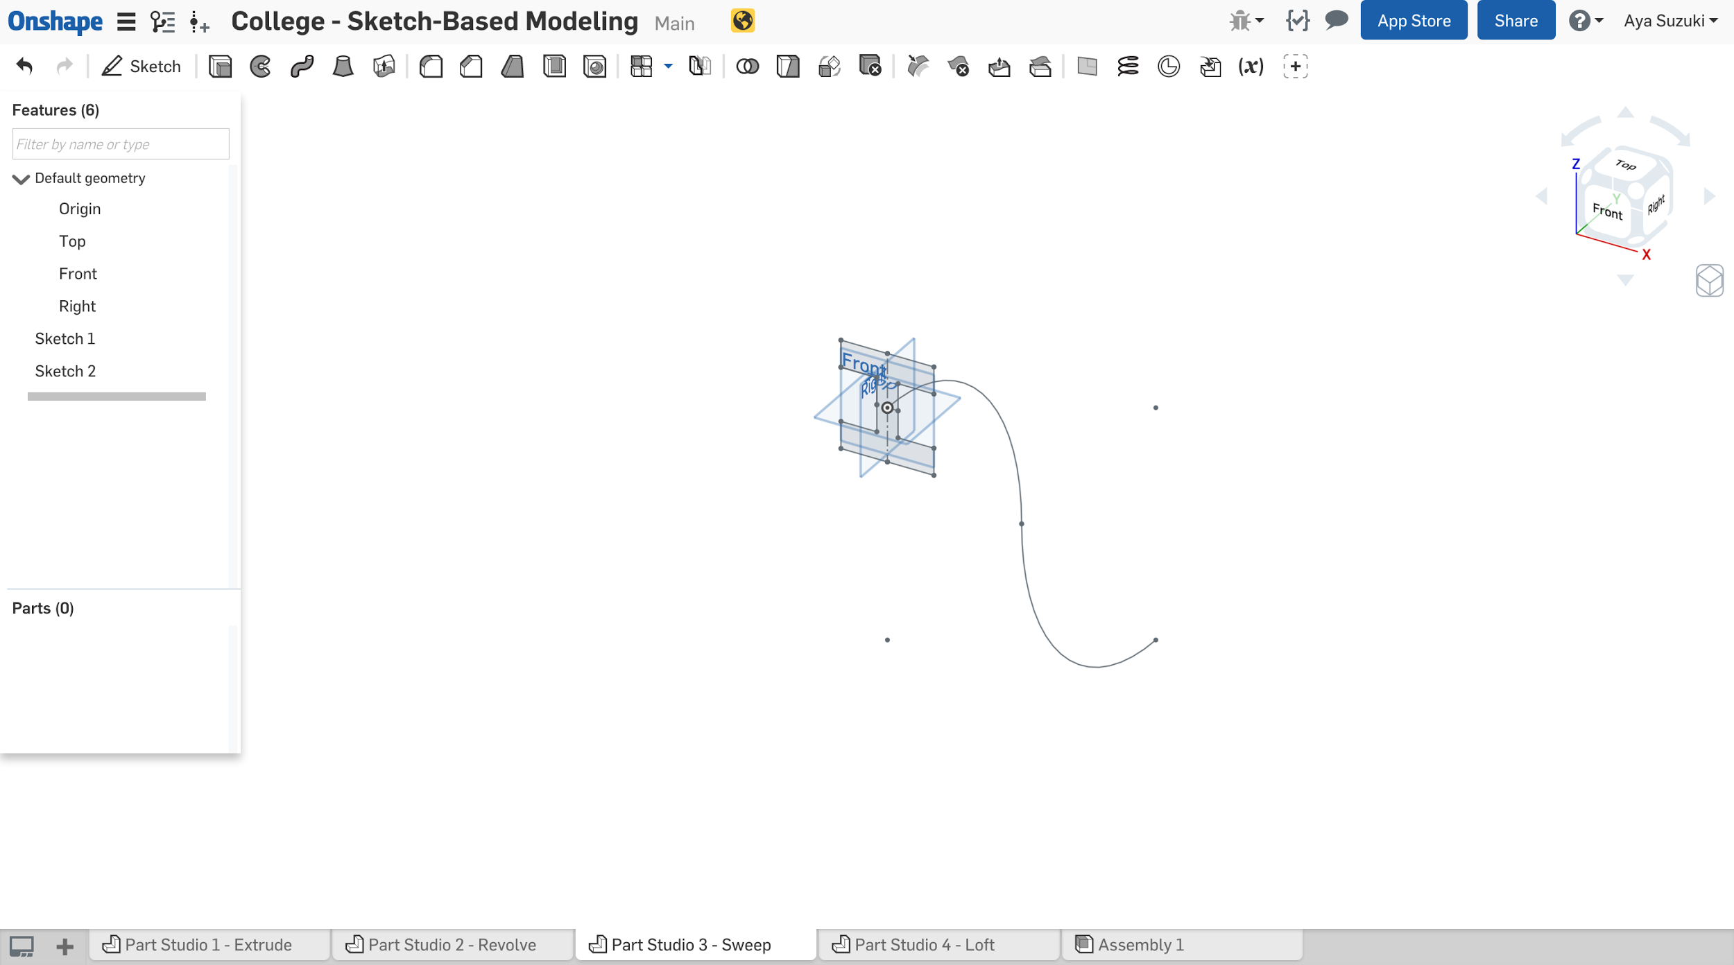

1. Let’s think about how we can use these 2D sketches as profiles for a 3D model. What will happen when you drag this letter “I” along the “S” shaped curve? This idea of dragging a 2D sketch with a constant cross section along another 2D path is called **sweeping**.
2. Click on the Sweep tool . A dialog will show up.
3. For the first highlighted field (“*Faces and sketch regions to sweep*”), click on the “I” sketch.
4. Click on “*Sweep path*”. Then select the “S” curve. The dialog box should end up looking like this:

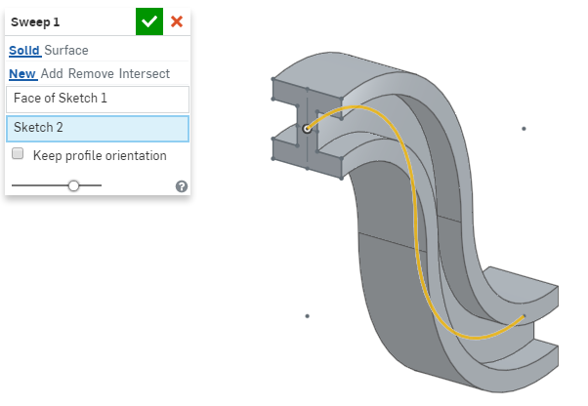

*Pro Tip: In this case, Sketch 2 was selected from the Feature List, not from the main Graphic screen. Onshape accepts either, but in this case, selecting from the Graphic screen would require two selections (one for each arc). When sweep paths are long and complicated, selecting the entire sketch from the feature list can save a lot of time.*

1. Click the green check mark  to accept.
2. You have successfully created a 3D model (the I-beam) from 2D sketches (the “I” and the “S”) by **sweeping**!

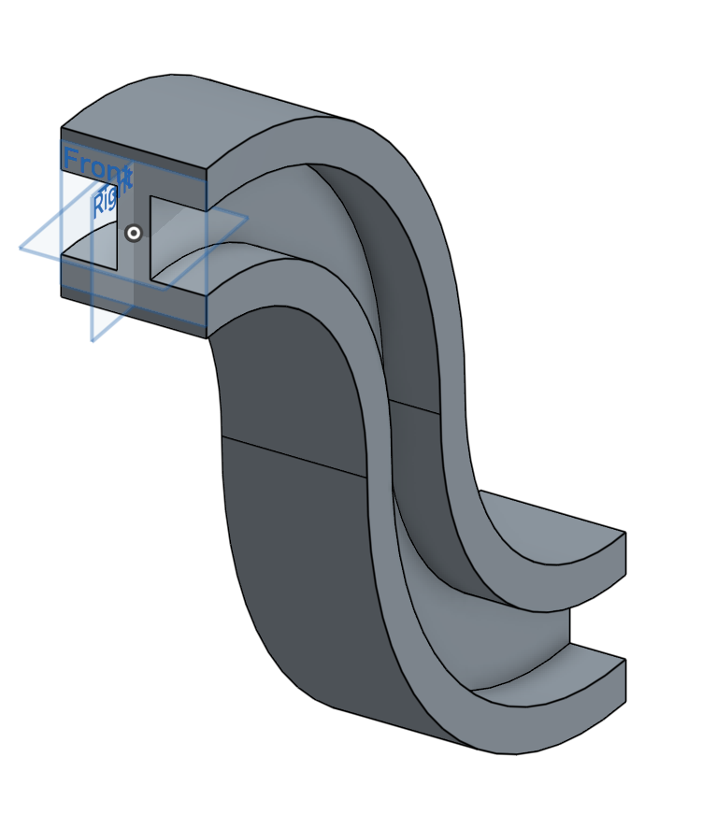

## Loft

1. Finally, let’s **loft** a sketch. Click on “Part Studio 4 - Loft”. You’ll see 2 sketches, one on top of the other, like this:

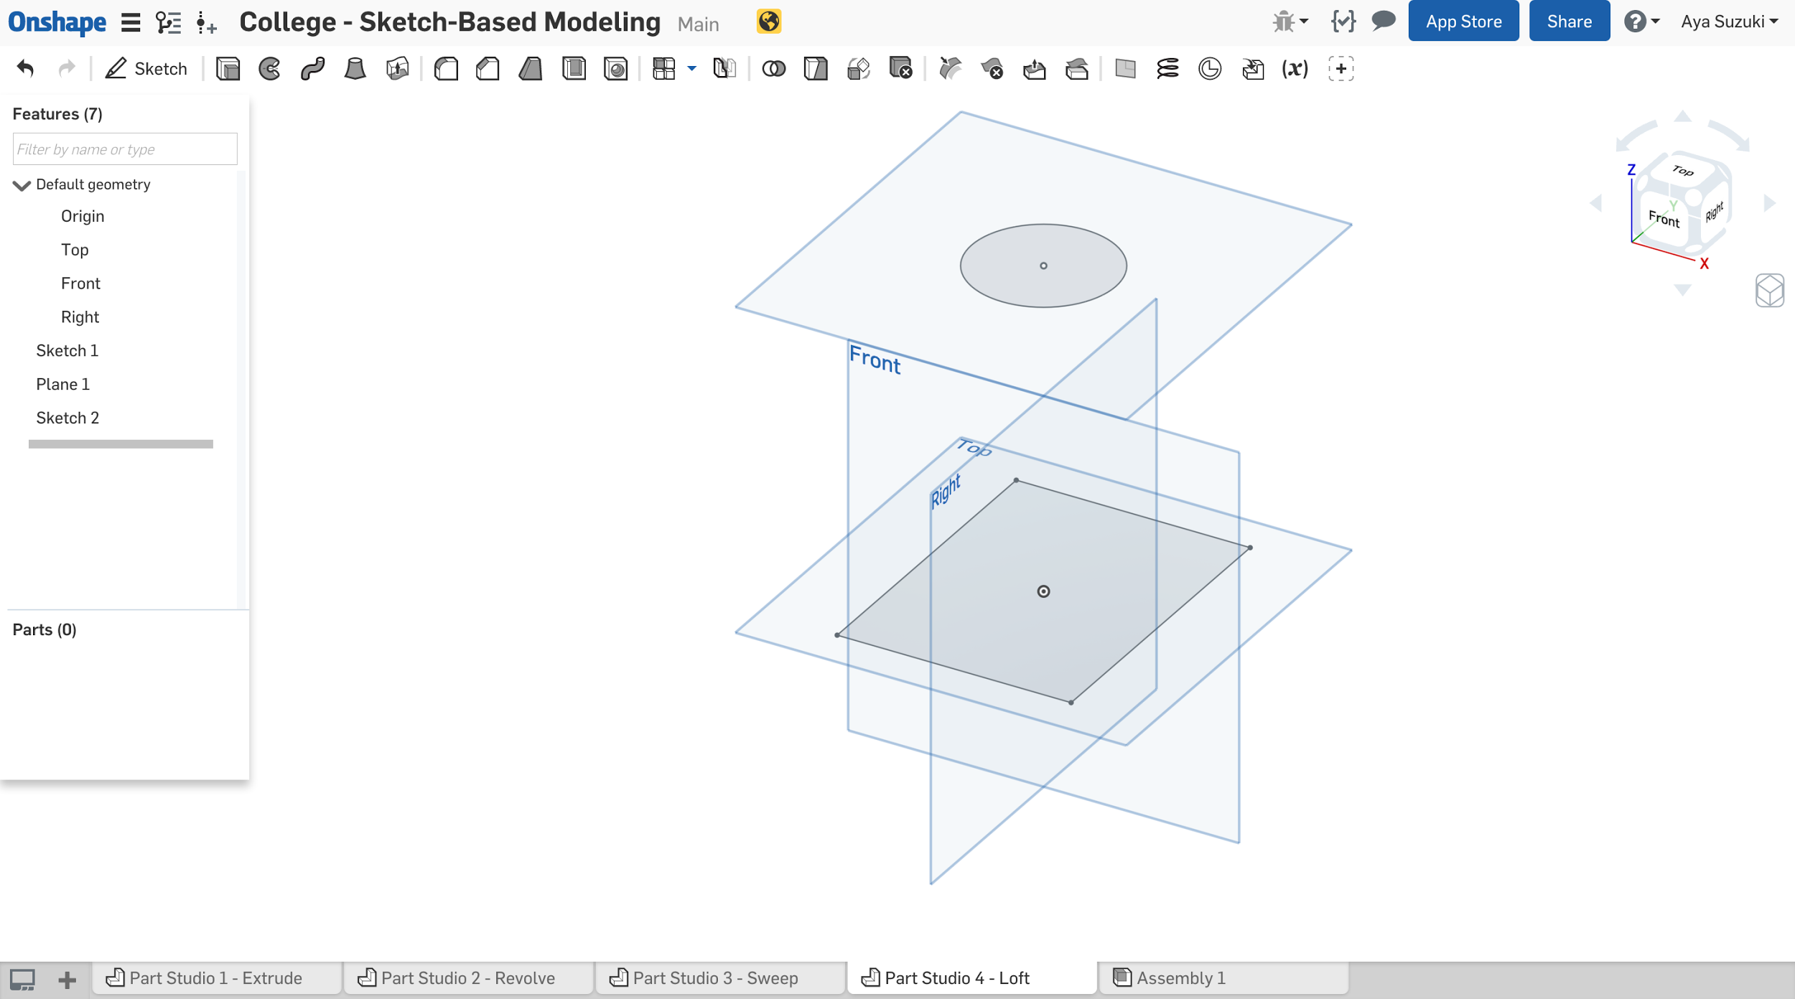

1. Let’s think about how we can use these 2D sketches as profiles for a 3D model. Imagine a 3D solid with a rectangular base and a circular top. This idea of smoothly connecting multiple cross sections is called **lofting**. We can imagine a 3D solid like this:

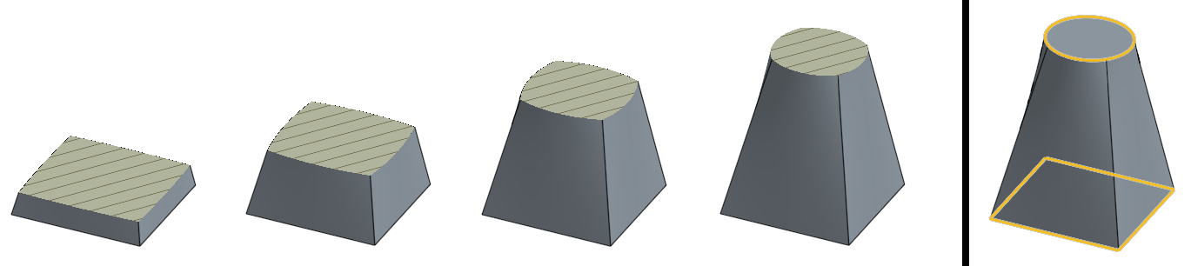

As we can see on the left, the cross-section (with the cross hatch lines) of the geometry slowly changes from a perfect square at the bottom to a perfect circle at the top.

1. Click on the Loft tool . A dialog will show up.
2. Under the “*Profiles*” field, click on both the rectangle and circle. The dialog box should end up looking like this:

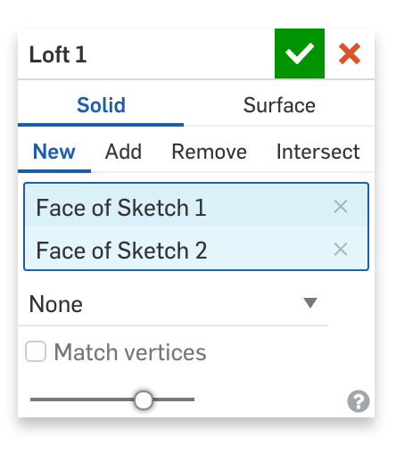

1. Click the green check mark  to accept.
2. You have successfully created a 3D model from 2D sketches (rectangle and circle) by **lofting**!

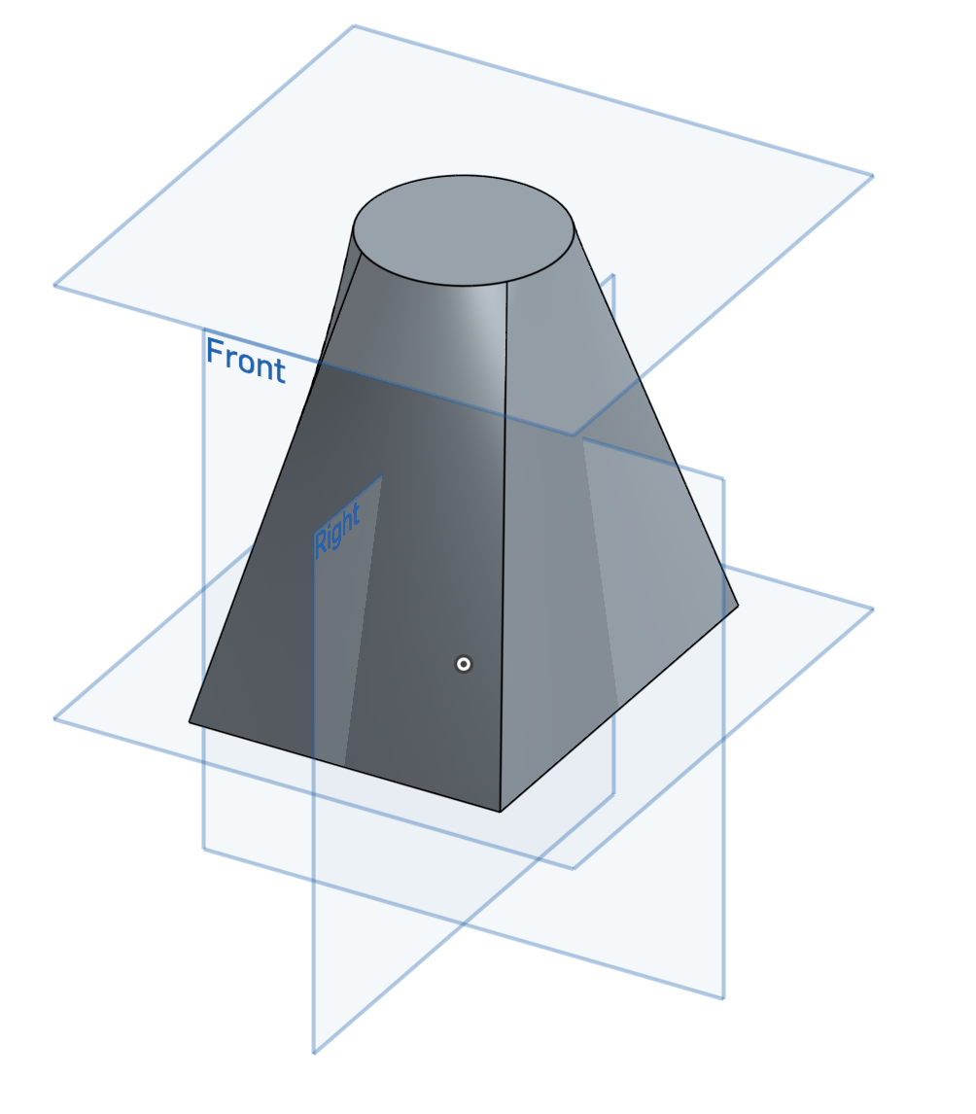

To summarize what we’ve learned so far:

* To create 3D geometry, we first start off with a 2D sketch, and then we perform an operation on it. So the workflow for creating a single 3D feature often goes something like this:
  1. Pick a plane
  2. Sketch a 2D profile on it
  3. Create a 3D feature by referencing the previously-sketched profile
* This workflow is quite unique to CAD software, but is not unique to Onshape. Besides a few exceptions, most CAD programs will have a workflow exactly like this. It will become second nature quite soon, as it will be repeated dozens of times throughout the creation of a single part, and hundreds of times throughout a large assembly. For example, this is the feature tree of one of the previous parts, note the familiar 2D sketch/3D feature pattern:

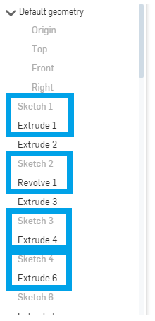

* In addition to the workflow, most CAD programs include the four foundational features. Let’s recap these four features one more time:
  1. **Extrude:** This geometry is created when a constant cross section is extruded in a straight direction.
  2. **Revolve:** This geometry is created when a constant cross-section is revolved around an axis of revolution.
  3. **Sweep:** This geometry is created when a constant cross-section is swept along a path.
  4. **Loft:** This geometry is created when multiple cross sections are smoothly connected together.

Every object around you, including your pen, your USB cable, and the keys on your keyboard, was designed by someone, and was most likely created by some combination of these 4 foundational features. Take a look around you and think about how the objects you see might have been created using these features. These four features, when used together, can create just about any geometry in the world!

# Sketching: My Very First Part

So far you’ve used pre-made sketches to create 3D geometry using the concept of sketch-based modeling on the four foundational features. Now, it’s time to make your own 3D model from scratch!

To be extra prepared, you can review the help section and watch Onshape’s videos on how to use Sketch Tools: [Onshape Help: Sketch Tools](https://cad.onshape.com/help/#sketch-tools.htm%3FTocPath%3DPart%2520Studios%7CSketch%2520Tools%7C_____0)

As we go along, it is likely that you will make a mistake – that’s okay! If you make any sketch geometry that you’d like to get rid of, simply refer to the sub-section titled “Selecting and Deleting” to select and delete any sketch entities.

Let’s get started.

## Creating a New Document

1. Go back to the Documents page, by clicking the  button in the top left corner of the screen.
2. Click the  button, and the following screen will pop up:

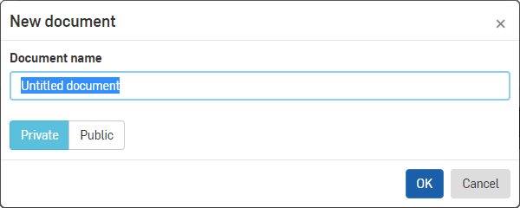

1. Enter a name for your document, such as “My Very First Part”.
2. Keep the document Private (more on this topic later), and click [OK].

## Default Geometry

When we create a new Document, we might expect the Document to be empty, but we end up in what’s called a **Part Studio** with four premade features. This group of features is called the “Default geometry”, and it consists of the **Origin** and the three default planes: **Top**, **Front**, and **Right**. The origin is the intersection of the 3 default planes, as shown here:

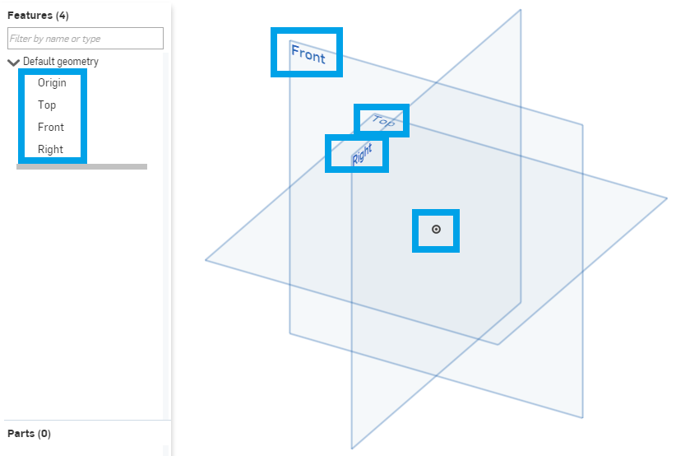

The default geometry can never be moved; however, the planes may be resized as needed. Once a plane is selected, it highlights yellow and the corners (which are highlighted by blue circles) may be dragged. This is just a visual change - no actual geometry is affected. These types of geometries (planes and the origin) are types of a broader category called Reference Geometry (which we’ll go into more depth on later).

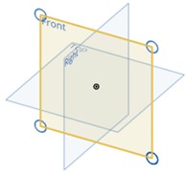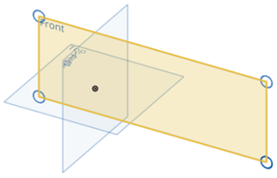

## Drawing and Extruding a Star

Let’s get back to making our first real part. We’ll begin by sketching a star.

1. Create a new sketch by clicking on the  button.

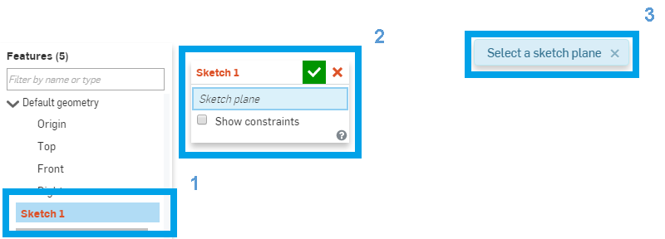

*Note: 3 things pop up on the screen:*

1. *A new Sketch is created in our Feature List, colored red because it is still being defined, and highlighted blue.*
2. *The Sketch Dialog box opens up, and prompts us for a Sketch plane (also highlighted in blue).*
3. *A message in the middle of the screen appears prompting us for a sketch plane.*
4. Select the Front plane. This defines what 2D plane you will be sketching on.
5. Select the Line tool . Click on the origin, move the mouse, and click again for the end of the line. A new line is started, connected to the first. This is called a sketch chain.

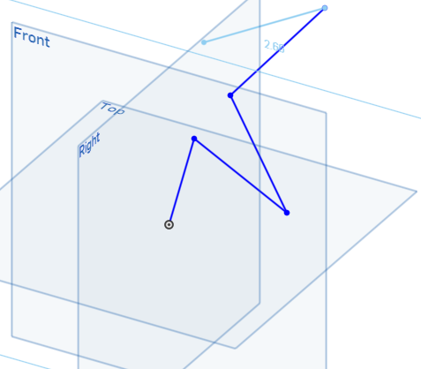

*Pro Tip: You can select any tools in the toolbar by clicking on it. To deselect, click it again, or use the context menu and select “Exit <tool name>”, or press the* ***ESC*** *key.*

*Pro Tip: Sometimes, it is easier to sketch when you are viewing the screen “straight on”, or in 2D. To quickly do this, hit the “****n****” key on the keyboard (this makes the sketching plane normal to the screen). Here is how the sketch looks after hitting the “****n****” key:*

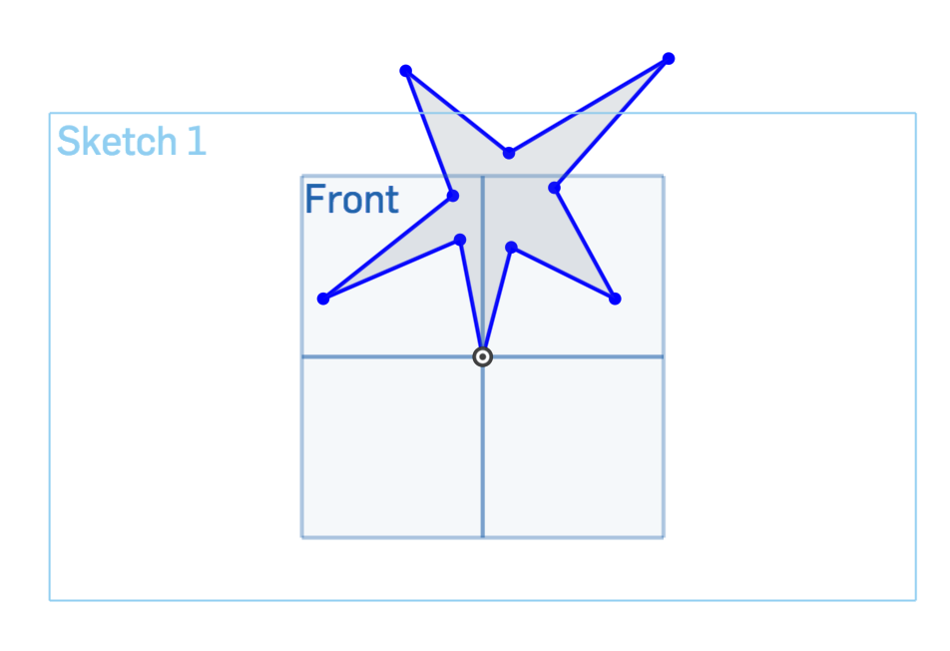

1. Keep repeating this until you have come back to the origin again. Onshape knows to stop sketching the chain once you reach the endpoint of another line. Onshape also conveniently shades our star in light blue, so we know it is a “closed contour”. Sketches must have a closed contour in order to create 3D solid geometry.

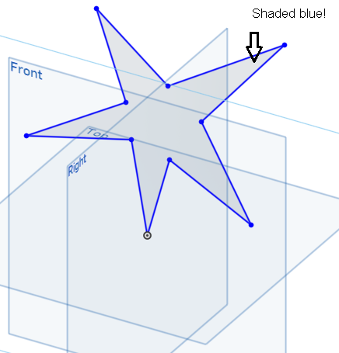

*Pro Tip: Always keep an eye out for the blue shade in a closed contour. It’s sometimes hard to see if all the lines touch each other. For example, here is an “open contour” star next to our properly sketched closed one. Without the blue shading, it would be nearly impossible to see the small gap at the origin:*

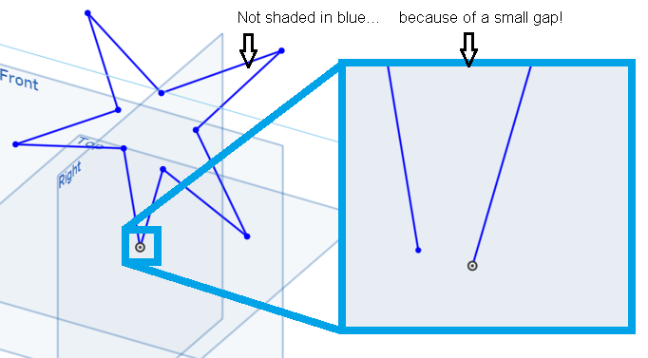

1. Accept the sketch with the green check .
2. Now click on the Extrude tool .
3. Click on the star sketch.
4. You can click and drag the arrow to control the depth of the extrusion. You can also specify an exact depth by typing in the dialog. Specifying an exact dimension can be very helpful when creating precise parts, which will come in handy once you start making more complex designs. Let’s extrude the star by 2 inches (don’t worry, we will be using metric in this curriculum too!).

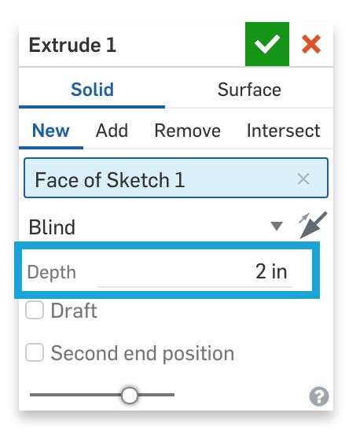

1. Let’s change the direction of extrusion. To do that, either click on the arrows  in the dialog box to change the direction of the extrusion or click on the arrow coming out of the extruded preview model.

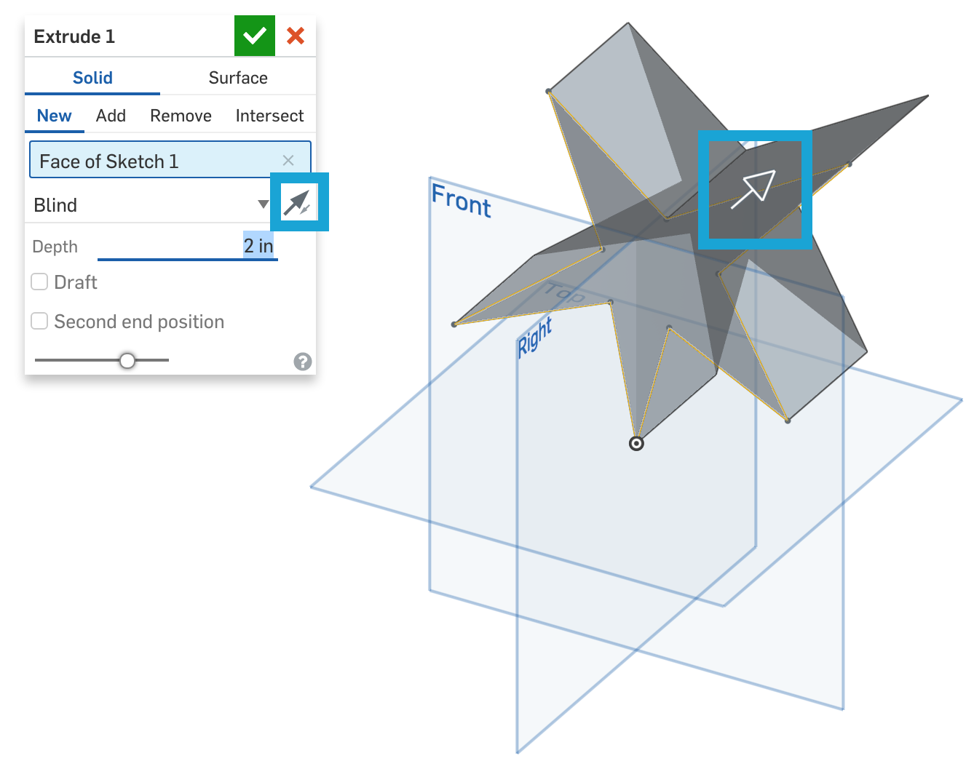

1. Click the green check box  and you’re done!

*Pro Tip: Onshape saves everything automatically, so note that there is no save button.*

## Selecting and Deleting

Everyone makes mistakes while sketching. This section teaches you how to select and delete sketch entities.

1. To follow along, delete “Extrude 1” from the left panel in your star example. Right click “Extrude 1” and select “Delete”.

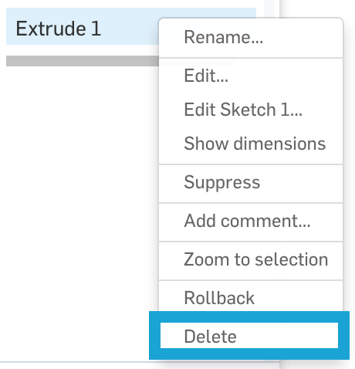

1. Onshape selection works like a toggle. Click on one of the lines in the star to select, click again to deselect. Notice that when you select an entity, it is highlighted.
2. You can also select multiple sketch entities. Click on one line, then click another. Two lines in your star will be selected. Just keep clicking to select more sketch entities. The cursor will display a count of selected entities, but it’ll only be accurate up to 5 entities.

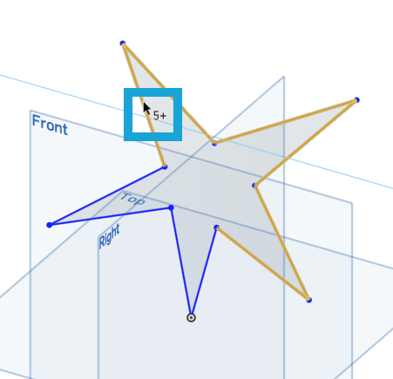

1. If you want to select multiple sketch entities at once, you can drag a selection box around or across entities.

*Pro Tip: The box select is really smart! It does different things, depending on how you draw the box. Drag* ***left-to-right*** *to select the entities that fall* ***entirely within the box*** *(indicated by solid blue outline and blue-shaded selection box). Drag* ***right-to-left*** *to select the entities that* ***the box touches*** *(indicated by dotted yellow outline and yellow-shaded selection box). Try it now!*

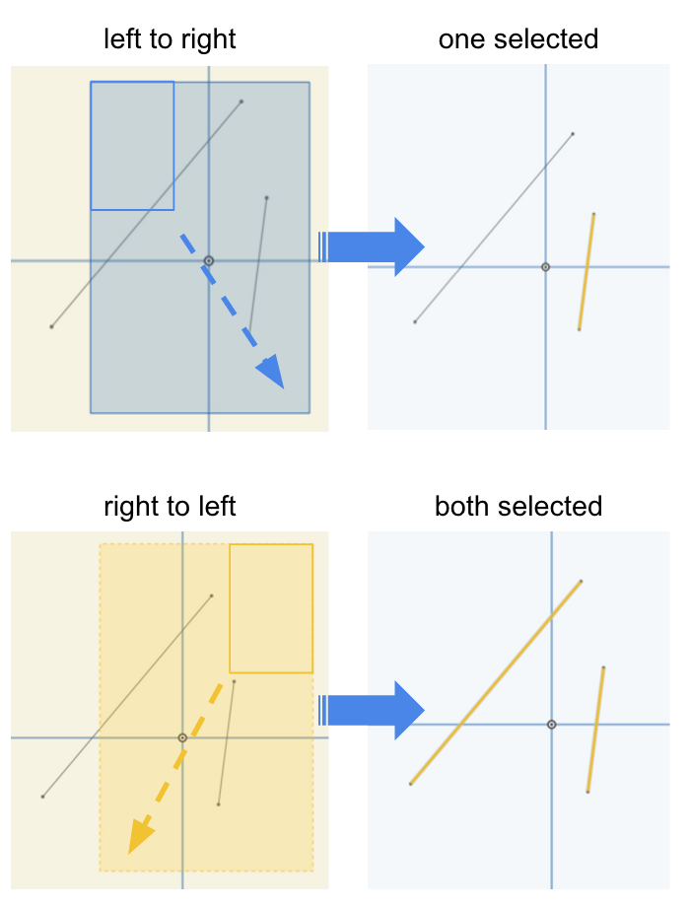 

1. You can clear all your selections by:
   1. Clicking in empty space
   2. Pressing the spacebar
   3. Choosing “Clear selections” from the context menu

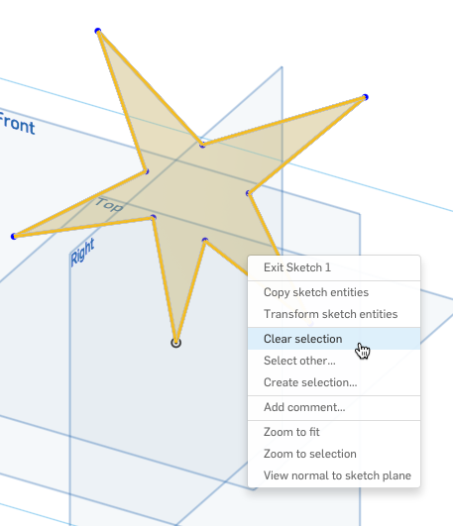

1. After selecting the sketch entities, you can delete them by pressing the **delete** key, or right-clicking and selecting “Delete [number] sketch entities”.

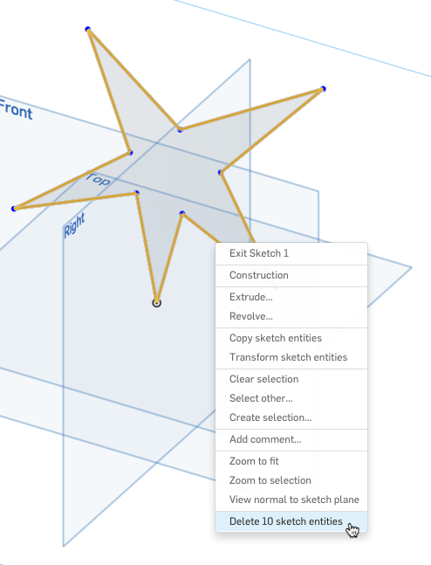

*Pro Tip: You can also undo commands by clicking the Undo command**, or pressing* ***CTRL-Z****.*

# Sketching: Part 2

1. Start a new part studio by clicking on the “+” icon on the bottom left corner of the screen, and selecting “Create Part Studio”:

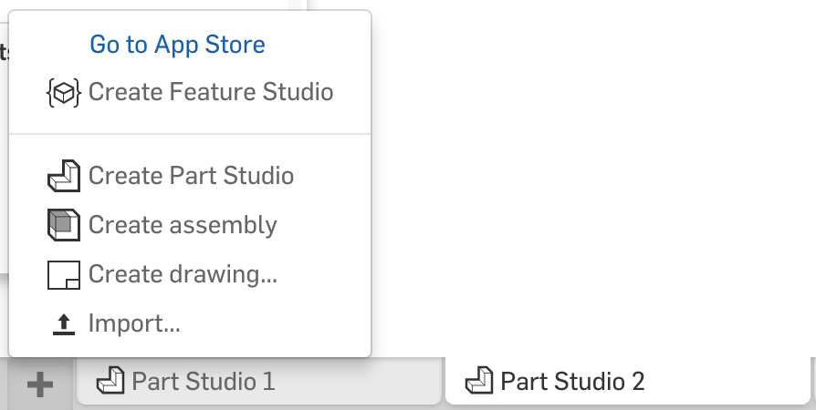

1. Create a new sketch on the Front plane. This time, let’s create a rectangle, using the “center point rectangle” tool from the rectangle pull-down:

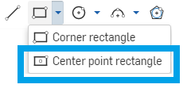

1. Draw a rectangle at the origin by clicking the origin first, something like this:

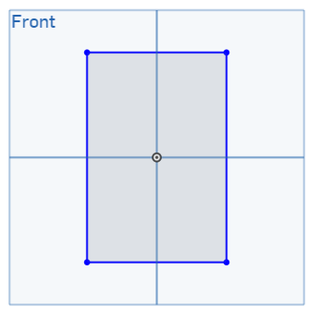

1. New, select the circle tool , and hover the mouse over the center of the top line. It should highlight orange, and show a little icon  (The mouse is “snapping” to the midpoint of the line):

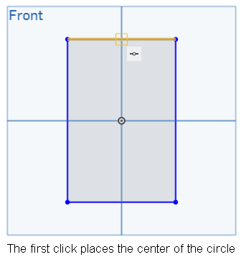

*Pro Tip: This small icon symbolizes a* ***constraint*** *on the sketch entity. In the example above, we drew the sketch such that the center of the circle is* ***constrained*** *to be at the midpoint of the highlighted line. Constraints are an integral part of sketch-based modeling and we will spend a lot of time learning about them in the next lesson.*

1. Draw your circle here, and make it the same width as the rectangle. The mouse should snap to the top corner of the rectangle:

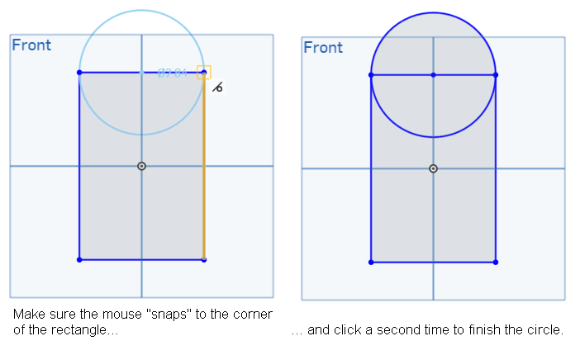

1. Next, draw another, smaller circle, concentric with the first:

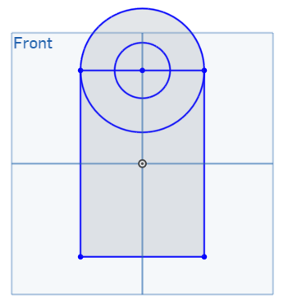

*Pro Tip: Instead of drawing a circle in Step 5, you could also use the “Center point arc”, located next to the Circle tool in the toolbar.*

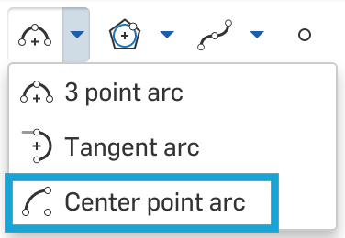

*Snap the center of the arc to the midpoint of the line, then click the two endpoints of the line.*

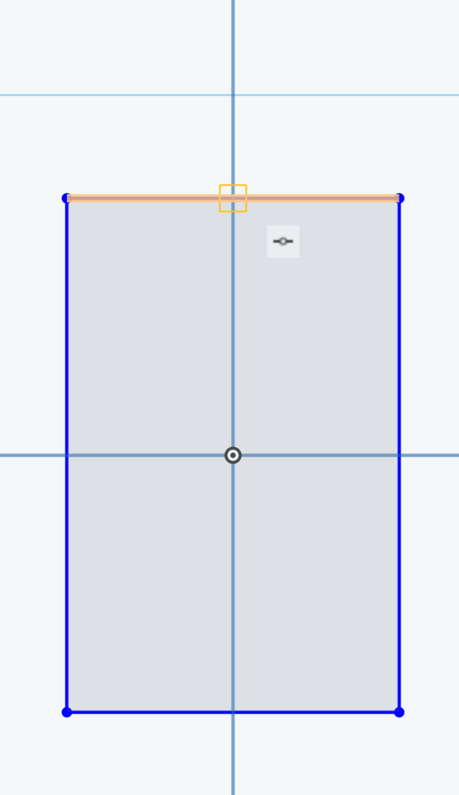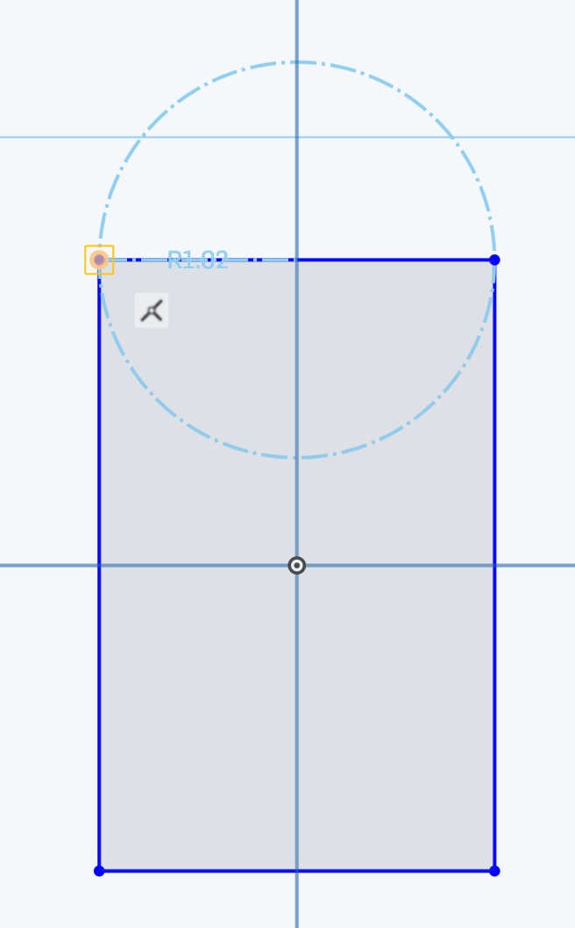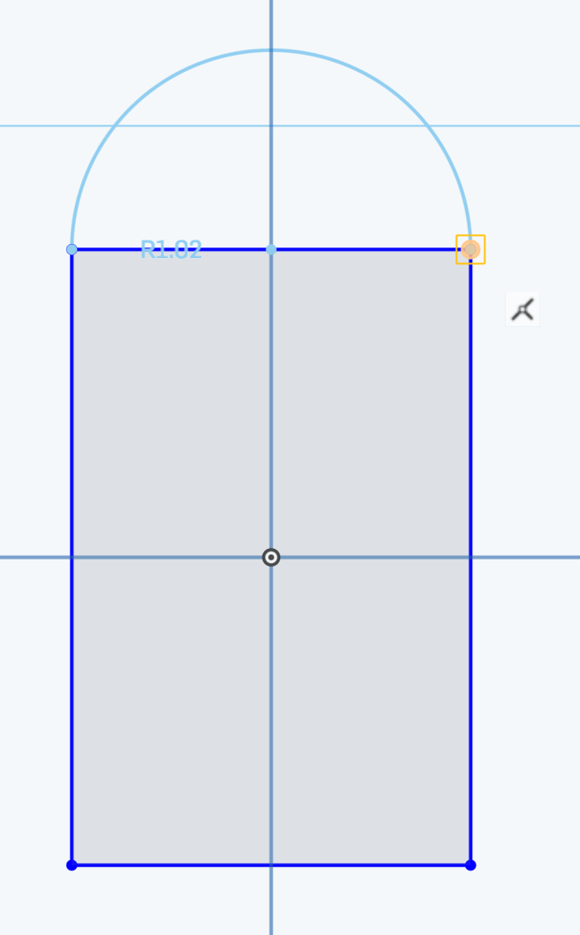

*Your sketch will look like this after adding the circle from Step 6:*

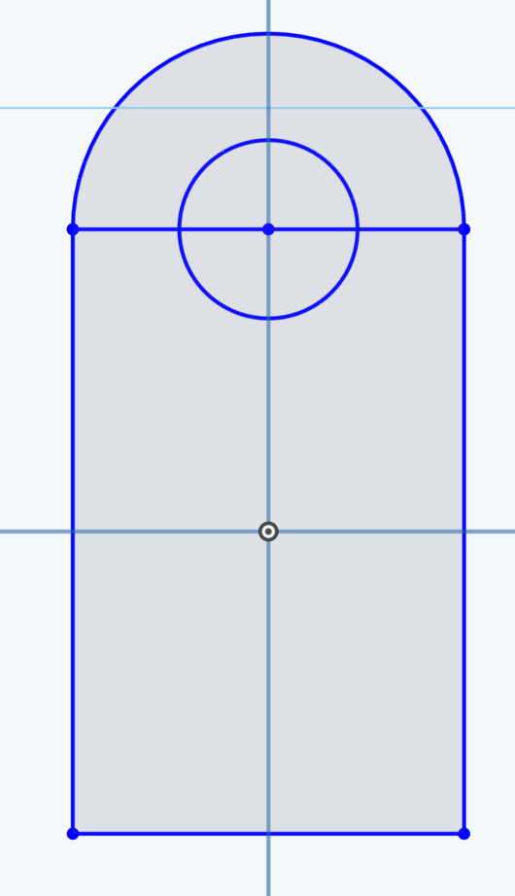

1. Next, select the trim tool , and click on the segments of the rectangle (if you drew a full outer circle in Step 5, click on the bottom half of the outer circle as well) to remove them, until you end up with a sketch like this:

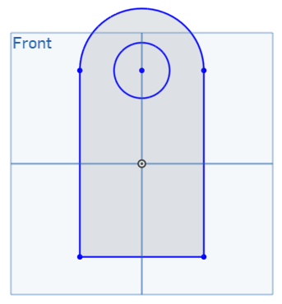

1. Accept the sketch with the green check mark . This sketch is now complete and it’s time to extrude.
2. Select the extrude tool, select the sketch profile, and then extrude it by 1.25”:

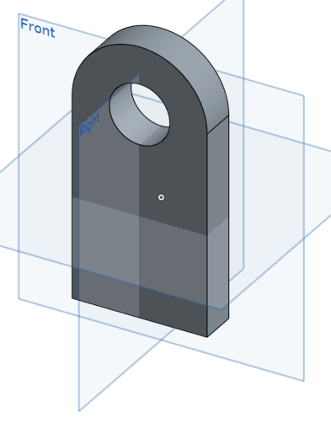

1. Notice how Onshape automatically creates a hole during the extrusion, because we drew a circle inside the sketch.

# Sketching: Part 3

1. Let’s create a bracket, which might be used within a larger machine. Start by creating a new part studio. Create a new sketch on the front plane, and draw a rectangle with its corner at the origin. This time, use the “corner rectangle” tool :

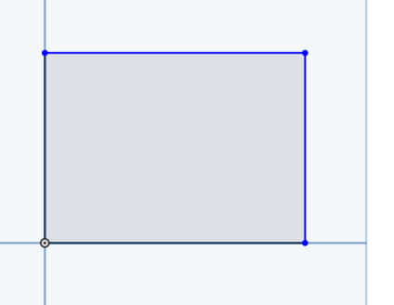

1. Next, draw another rectangle aligned to the top of the first one:

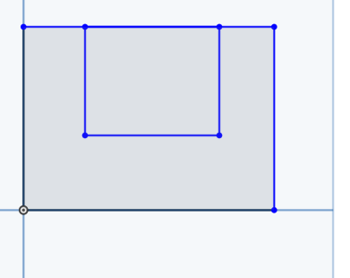

1. Use the trim tool to remove the overlapping lines (there are two of them):

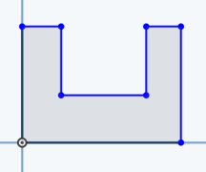

1. We want the two horizontal edges on the top to be equal. Select those, and click the Equal constraint . We’ll be learning about constraints next week, but all you need to know now is that the Equal constraint makes the edges have the same length, no matter what:

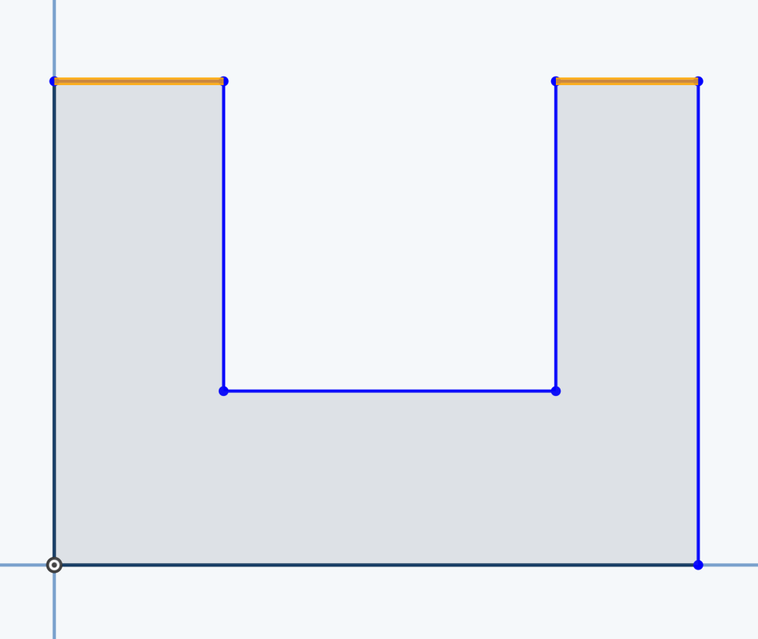

1. And extrude it out like this:

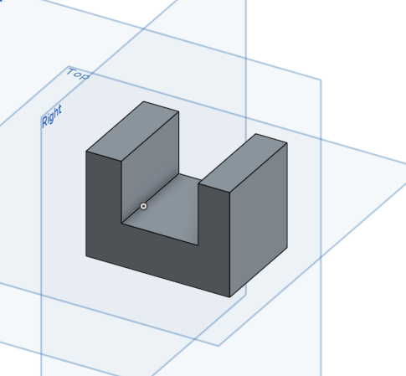

*Pro Tip: You could have also extruded the sketch to create the exact same solid without completing step 3. If you did not trim the sketch, you can select the “U” region of the sketch (not the square) from the graphics region and extrude that only.*

1. Next, let’s remove some material from it. Create a new sketch on the top surface of the bracket by clicking on the surface. Notice you don’t have to sketch on the blue reference planes, but can also sketch on any flat face of an existing part:

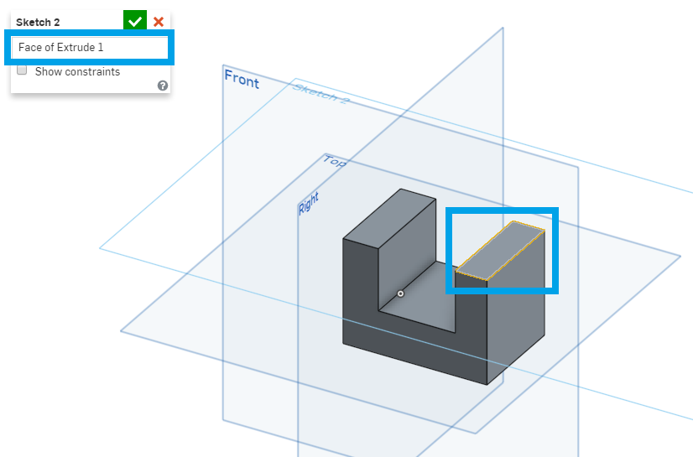

1. Sketch a new rectangle, that is aligned with the right side of the bracket, and accept the sketch. Onshape should snap to the edges of the part:

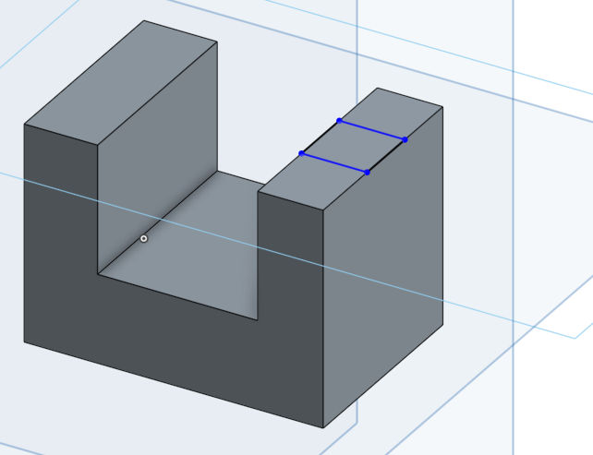

1. Now, let’s extrude this rectangle down. In the extrude dialog box, change the operation to “remove”:

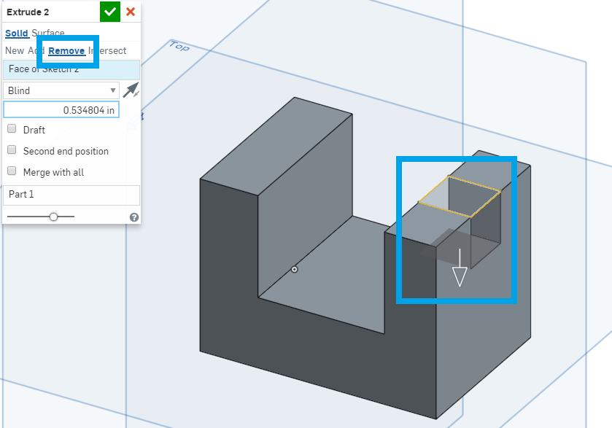

## In-Class Exercise #2:

Try to create the following parts by using the “Sketch>Pick a plane>Extrude” workflow. Keep an eye on the default planes! There are no size requirements - the purpose is to get the shape and orientation right, and to get comfortable with the workflow. Create each new part in the same document, but in a new Part Studio, just as before.

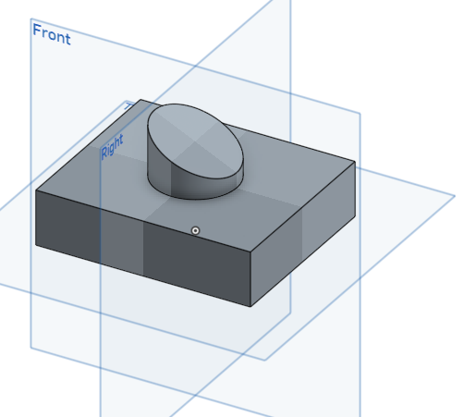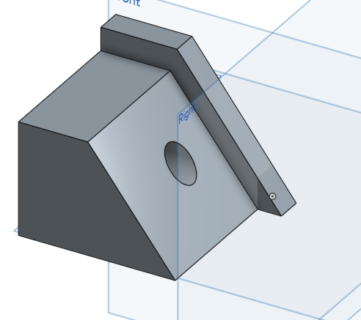

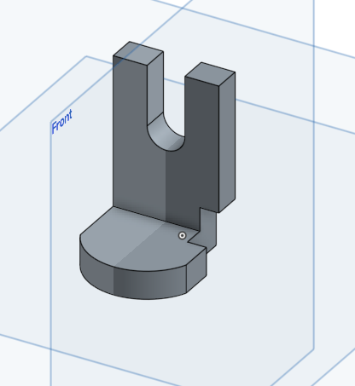 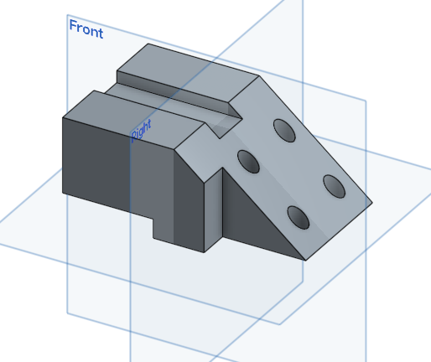

*For an extra challenge: Try to create the last shape in only 3 features!*

# Summary

Let’s take a second to reflect what we learned in this lesson.

1. We learned about the sketch-based modeling and the 4 foundational features (extrude, revolve, sweep, and loft).
2. We made our very first sketch.
3. We learned about selecting and deleting sketch entities.
4. We learned about snapping sketch entities to draw more accurate sketches.

Next week, we’ll be talking about dimensions and constraints, expanding more on the idea of creating accurate sketches.

# 

# 

# Appendix A:

# Below is more information. Many of them won’t make sense yet, but it’s good to know how to get them, as we will be using them later in the course.

# Keyboard Shortcuts

Activate the keyboard shortcuts map right in the user interface by pressing the Question mark key "**?**" on your keyboard when in a document. You can even pop it out of the window for continuous display:

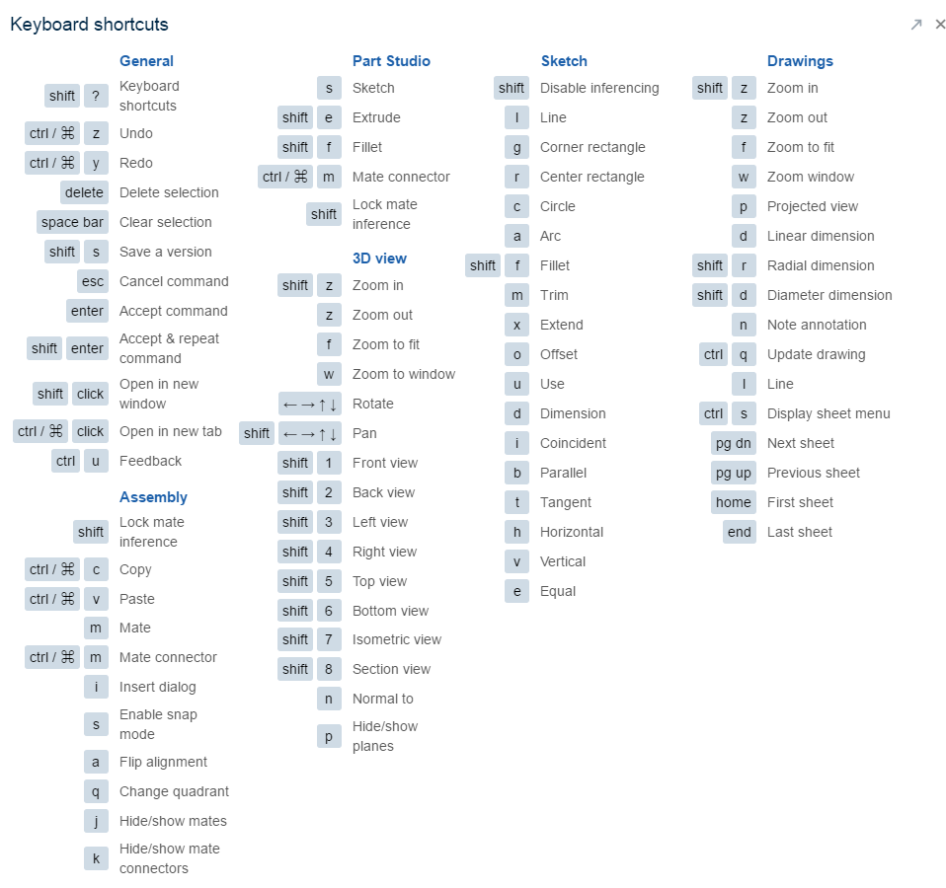

# 

# Mouse and Touchpad Gestures

Here is a summary on how to rotate, pan, and zoom.

***Windows***

|  |  |  |
| --- | --- | --- |
| *Mouse* |  | *3D rotate: Right-mouse-button-click+drag* |
|  |  | *Zoom in and out: Scroll up and scroll down, respectively* |
|  | *or* | *2D pan:****CTRL****-right-mouse-button+drag (middle button click+drag)* |
| *Touchpad* |  | *3D rotate: Right-mouse-button-click+drag* |
|  | *and* | *Zoom in and out: Pinch out and pinch in, respectively* |
|  |  | *2D pan:****CTRL****-right-mouse-button+drag* |

***Apple***

|  |  |  |
| --- | --- | --- |
| *Mouse* |  | *3D rotate: Right-mouse-button-click+drag* |
|  |  | *Zoom in and out: Scroll down and scroll up, respectively* |
|  | *or* | *2D pan:****CTRL****-right-mouse-button+drag (middle button click+drag)* |
| *Touchpad* |  | *3D Rotate: Hold with two fingers first, then release one finger and drag* |
|  | *and* | *Zoom in and out: Pinch out and pinch in, respectively* |
|  |  | *2D pan:****CTRL*** *+ Hold with two fingers first, then release one finger and drag* |

*Note: For easier use of the Apple Touchpad, go to Apple*  *> System Preferences > Trackpad and make sure “Secondary Click” is checked. My personal preference is to have secondary click in the bottom right corner. Then, I can click and hold in the corner with my thumb and move the cursor with my middle finger to rotate the model.*

# 

# View Tools

Besides moving the model within the screen, you can also change its appearance. Beneath the View Cube is a small View Cube icon, and within that menu is a variety of different ways to view the model. As the models get more complex, these visibility tools are helpful in allowing us to inspect and review our geometry. Here is a quick overview:

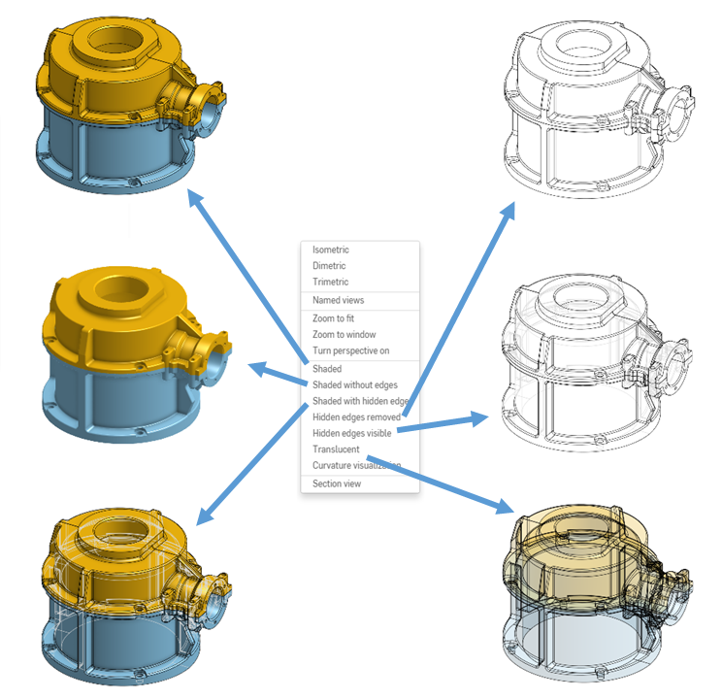

# Appendix B:

# More About Your Onshape Account

### Forgot Your Password?

Click the link next to “Forgot password?” on [http://cad.onshape.com](http://cad.onshape.com/) to receive an Onshape email containing a link to reset your password. Onshape doesn't save or record your password.

Note: The following sections refer to the Documents page that appears right after signing into your Onshape account at [http://cad.onshape.com](http://cad.onshape.com/).

### Views

The Documents page offers two types of views:

*  List view - (Default) Presents documents by name in a list view and includes the Detail pane to the right. Click the name to open the document (underlined upon hover), or click anywhere else in the line to select.

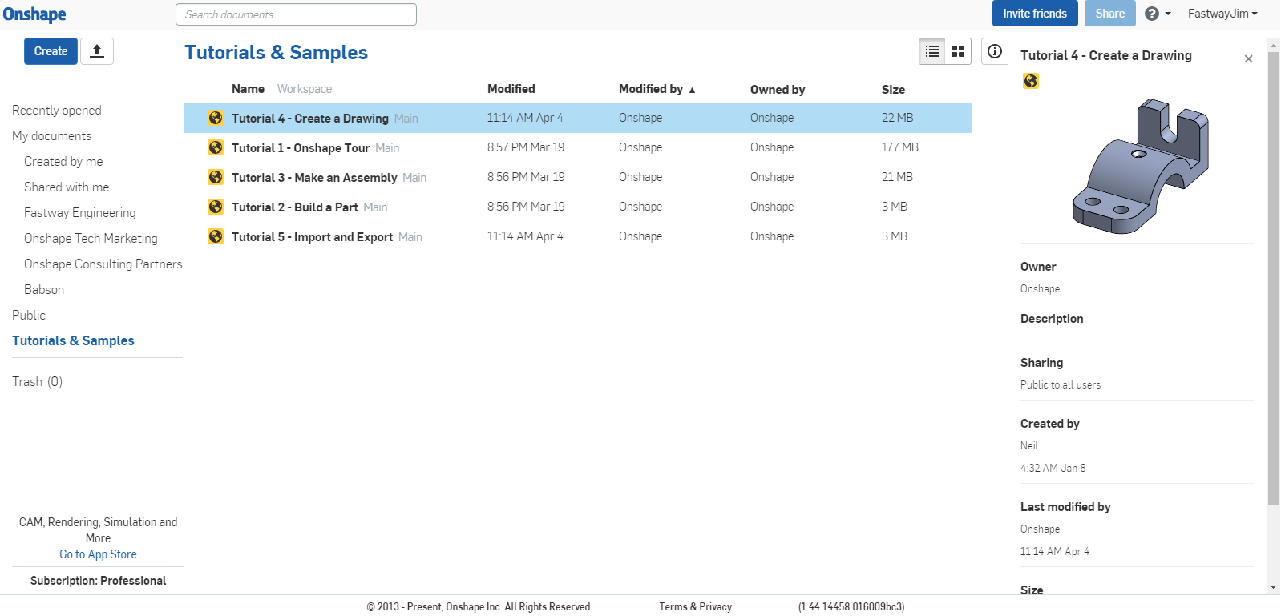

*  Grid view - Presents documents in a thumbnail view (thumbnails are of the last Part Studio accessed). The Details pane is closed but you can use the icon to open it again. Each thumbnail includes: Document name, owner, time last modified, size and Gear menu. To open a document, click the name. To select a document, click anywhere in the thumbnail.

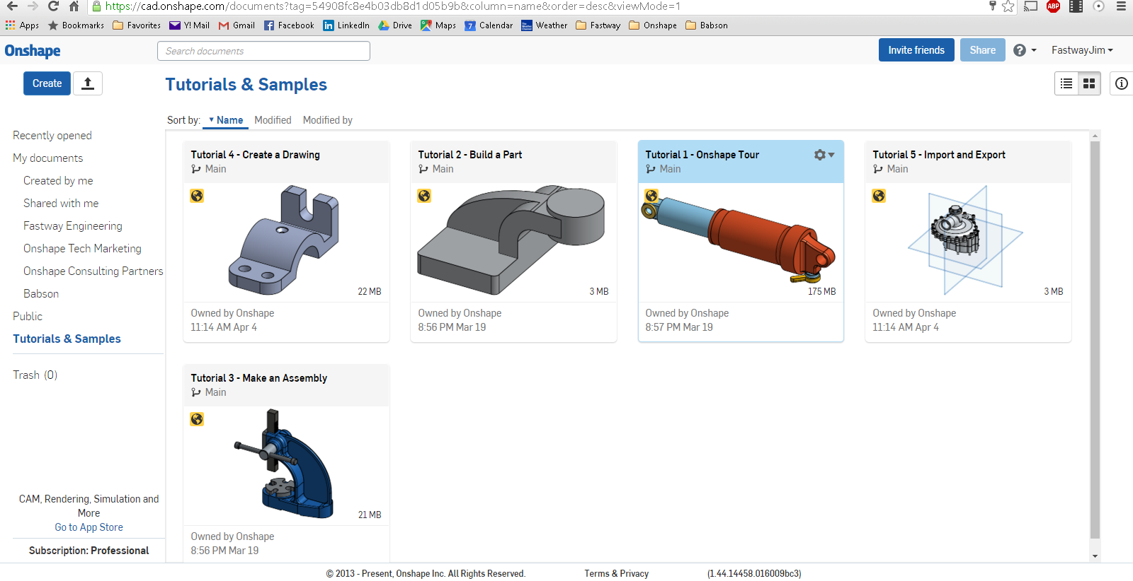

### Document Filters

On the left is a list of predefined filters to make finding documents easier. Click one to filter the list of documents:

* **Recently opened** lists documents most recently opened by you or another user with permissions to the document.
* **My documents** lists all documents you have created as well as all documents shared explicitly with you.
  + If you are part of any companies, those companies are listed in this area, by company name, under “My documents”.
  + **Created by me** lists those documents you have created yourself.
  + **Shared with me** lists all documents shared with you explicitly by another Onshape user or as part of a team or company.
* If the user is a member of a company plan or a team, those filters are inserted at this point in the list.
* **Public** lists all documents made publicly available to all Onshape users by another Onshape user.
* **Tutorials & Samples** lists all tutorials and samples provided by Onshape; these documents are read-only; feel free to make a copy for yourself in order to obtain edit privileges, which you can do by clicking the Gear icon and selecting “Copy workspace”.
* **Trash**lists all documents that you have deleted. Private documents in “Trash” still count towards your private document limit. Note that any documents you delete from the “Trash”, and all those present in “Trash” when you click [Empty Trash], are deleted forever.
* Click Details  in the upper right hand corner to toggle the document details area on and off. You can also view details about a specific document, access your user account, and sign out of Onshape.

### Share, Invite, and Import

You can also Share documents, Invite Friends to try Onshape, and import files:

*  Share documents - Send an email link to your document to any person. If they are an Onshape user, they can click the link and open the document in Onshape. If they are not yet a user, they are sent an invitation to sign up for an account and automatic Free plan, which will allow them to open your document. You can also make a document public; that is, available to all Onshape users. **Feel free to share documents with your friends and instructors - it’ll be helpful when you need help or guidance when making your models.**
*  Invite friends - Send an email invitation to a friend explaining how to sign up for an account and automatic Free plan.
* https://cad.onshape.com/help/Content/Resources/Images/icons/uploadafile.png Import files - Import other CAD files, as well as any other type of file (such as JPEGs, PDFs etc.), into Onshape.

### Units

Click on your user name in the upper-right hand corner, and select “Manage Account”. On the left-hand side of the screen, choose the option that says “Preferences”. This is where you can change your default units. They start with inch-degree-pound, but there are many options available. To change them, just pull down the menus, select, and hit [Save Units].

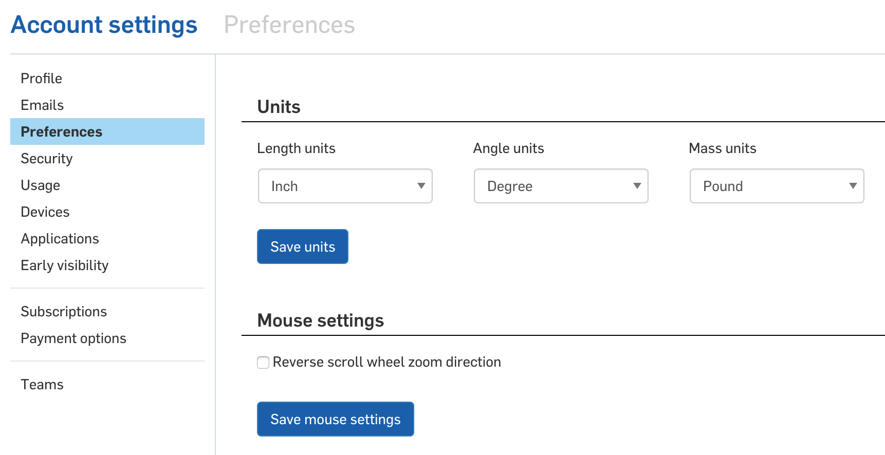

# A Note about Onshape Subscriptions

Onshape doesn't require any commitment on your part: you can sign up, create documents, make models, and export files, all for free. If you want to keep large numbers of documents private, it's best to upgrade to a [Professional subscription](https://cad.onshape.com/help/Content/plan-professional.htm).

## Free Subscription

The [Free Subscription](https://cad.onshape.com/help/Content/free-plan_active-documents.htm) is recommended for individuals who wish to try Onshape. Some limitations apply:

* You can create up to 10 private documents using up to 100MB private storage space. If you exceed either limit you are prevented from creating more private documents (until you free-up space), but you can continue to work on your existing private documents.
* You can create as many public documents as you wish, using up to 5GB total storage space (including private and public documents).
* Documents shared with you count toward the 10-private document limit, but not towards storage limits.

## Professional Subscription

The [Professional Subscription](https://cad.onshape.com/help/Content/plan-professional.htm) is recommended for users who want to create unlimited documents with unlimited storage space available. A Professional subscription can be purchased for $100/month and paid for at the billing interval of your choice (monthly or yearly). When signing up for the Professional subscription, you have the choice to sign up and pay as an individual or as a company.

## Education Subscription

Chances are, if you are reading this, you have an Education Subscription. This subscription is the same as the Professional, and is offered free of charge to students and teachers. The subscription expires after one year, at which point you are automatically downgraded to the Onshape Free subscription. However, you can upgrade to the Education subscription again, provided you still meet the criteria.

For more information and to sign up, visit <http://www.onshape.com/edu>.

All documents created in an Education subscription are marked with https://cad.onshape.com/help/Content/Resources/Images/icons/1xedu.png forever, even when made public, and even after the Education subscription has been downgraded. See [Canceling Education Subscription](https://cad.onshape.com/help/Content/cancel-eduplan.htm) for information on canceling an Education subscription.

### After Graduation…

After graduation, to upgrade to professional, you can downgrade to free, then upgrade to Professional.